**SMART WASTE MANAGEMENT SYSTEM**

**(A Case Study of Nairobi County)**

**PRESENTED BY:**

**DAVIS KIPRUTO**

**INDEX NO:206001/0212**

**COURSE CODE:2920/308**

**INSTITUTION NAME: NAIROBI INSTITUTE OF BUSINESS STUDIES (NIBS TECHNICAL COLLEGE)**

**TRADE PROJECT SUBMITTED TO KENYA NATIONAL EXAMINATION COUNCIL FOR PARTIAL FULFILLMENT OF THE AWARD OF DIPLOMA IN INFORMATION COMMUNICATION TECHNOLOGY**

**EXAMINATION SERIES: NOVEMBER 2025**

DECLARATION

**STUDENT DECLARATION**

I, **Davis Kipruto**, declare that this project documentation titled *Smart Waste Management System* is my original work and has not been submitted to any other institution for academic credit or examination purposes. I present this project for the awarding for Diploma

Name: Davis Kipruto

Sign:­­­­­­­­­­­­­­­­­­­­­­­­­­­­­________________________________

Date:________________________________

**SUPERVISOR DECLARATION**

Name: Mr. Felix Mumo

Sign:_________________________________

Date:__________________________________

DEDICATION

I dedicate this project to my beloved family, friends, and mentors who have continually inspired and encouraged me throughout my academic journey. Their support, motivation, and faith have been the driving force behind my success and determination to complete this project**.**

ACKNOWLEDGEMENT

I wish to express my deepest gratitude to the Almighty God for granting me wisdom, good health, and perseverance during the entire process of developing this project.

My sincere appreciation goes to my supervisor Mr. Felix Mumo for their guidance, feedback, and valuable insights throughout the research and documentation period. I am also grateful to my lecturers and classmates at the Nairobi Institute of Business Studies (NIBS) for their continuous support, collaboration, and encouragement.

Lastly, I extend special thanks to my family and friends for their patience and understanding, which enabled me to complete this project successfully.

**TABLE OF CONTENTS**

DECLARATION ii

DEDICATION iii

ACKNOWLEDGEMENT iv

LIST OF TABLES ix

LIST OF FIGURES x

ABSTRUCT xi

1. CHAPTER ONE 1

1.1. Introduction Background of the Study 1

1.2. Statement of the Problem 2

1.3. Objectives of the Study 3

1.3.1. General Objective 3

1.3.2. Specific Objectives 3

1.3.3. Other Objectives 4

1.4. Research Questions 4

1.5. Purpose of the Study 4

1.6. Justification of the Study 5

1.7. Scope of the Study 5

1.8. Limitations of the Study 6

1.9. Resource 6

1.9.1. Software Requirements 7

1.9.2. Hardware Requirements 7

1.10. Budget and Expenses 7

1.10.1. Budget 7

1.10.2. Duration 8

CHAPTER TWO 10

2.1. Introduction 10

2.2. Review of Theoretical Literature 10

2.2.1. Concept of Smart Waste Management 10

2.2.2. Information and Communication Technology (ICT) and Environmental Sustainability 11

2.2.3. Internet of Things (IoT) and Data Analytics in Waste Management 12

2.2.4. Theoretical Models Underpinning the Study 12

2.3. Review of Empirical Literature 13

2.3.1. Global Studies 13

2.3.2. African Context 13

2.3.3. Studies Conducted in Kenya 14

2.4. Conceptual Framework 14

2.5. Summary and Research Gaps 15

CHAPTER THREE 17

3.1. Introduction 17

3.2. Research Design 17

3.3. Target Population 18

3.4. Sampling Procedures and Sample Size 18

3.5. Data Collection Methods and Tools 19

3.5.1. Primary Data Collection 19

3.5.2. Secondary Data Collection 19

3.5.3. Data Collection Instruments 19

3.6. System Development Methodology 20

3.6.1. System Analysis 20

3.6.2. System Design 20

3.6.3. System Development 20

3.6.4. System Testing 20

3.6.5. System Deployment 21

3.6.6. Maintenance and Improvement 21

3.7. Data Analysis Techniques 21

3.8. Ethical Considerations 21

3.9. Summary 22

CHAPTER FOUR 23

4.1. Introduction 23

4.2. Presentation of Findings 23

4.2.1. Questionnaire return rate 23

4.2.2. Respondent Characteristics 24

4.2.3. Analysis of Responses According to Research Objectives 27

4.2.4. Objective 1: To Assess the Level of Awareness and Understanding of the Smart Waste Management System Among Citizens 27

4.2.5. Objective 2: To Determine the Efficiency of the Current Waste Collection and Disposal Practices 28

4.2.6. Objective 3: To Evaluate the Benefits of Implementing a Smart Waste Management System 28

4.2.7. Objective 4: To Identify the Challenges Facing the Implementation of Smart Waste Management Systems 29

4.2.8. Objective 5: To Suggest Strategies for Effective Adoption of the Smart Waste Management System 30

4.3. Data Analysis 30

4.4. System Analysis 31

4.4.1. Introduction 31

4.4.2. Existing System Overview 31

4.4.3. Weaknesses of the Existing System 32

4.4.4. Proposed System Overview 32

4.4.5. Features and Advantages of the Proposed System 33

4.4.6. Functional Requirements 34

4.4.7. Non-Functional Requirements 34

4.4.8. Software Requirements 35

4.4.9. Hardware Requirements 35

4.4.10. Data Flow Diagram (DFD) 36

4.4.11. Use Case Diagram 37

4.5. System Architecture 37

4.6. Interface Design 39

4.7. System Flow 39

4.7.1. Homepage or Landing Page 40

4.7.2. Login Interface 40

4.7.3. Create Account / Registration Page 41

4.7.4. Citizen Dashboard 41

4.7.5. Report Waste Interface 42

4.7.6. Reward Center Interface 42

4.7.7. Q&A (Help Center) Interface 43

4.7.8. Collection Schedule Interface 44

4.7.9. Environmental Hub Interface 44

4.7.10. My Profile Interface 45

4.7.11. Users Management Interface (Admin) 45

4.7.12. Administrator Dashboard 46

4.8. Database Tables 46

4.8.1. users Table 46

4.8.2. zones Table 47

4.8.3. bins Table 47

4.8.4. routes Table 47

4.8.5. route_bins Table 48

4.8.6. 4.6.6. collection_schedules Table 48

4.8.7. waste_reports Table 49

4.8.8. reward_points Table 49

4.8.9. reward_redemptions Table 50

4.8.10. point_rules Table 50

4.8.11. payt_bills Table 51

4.8.12. feedback Table 51

4.8.13. maintenance_logs Table 52

4.8.14. alerts Table 52

4.8.15. system_logs Table 53

4.8.16. payment_requests Table 53

4.8.17. content_management Table 54

4.9. System Implementation 54

4.9.1. Login Module 55

4.9.2. User Registration Module 56

4.9.3. Dashboard Module 57

4.9.4. Report Waste Module 57

4.9.5. Reward Center Module 58

4.9.6. PAYT Billing Module 58

4.9.7. Collection Schedule Module 59

4.9.8. Environmental Hub Module 59

4.9.9. Q&A Module 60

4.9.10. Feedback Module 60

4.9.11. Notification and Alert Module 61

4.9.12. My Profile Module 61

4.9.13. Users Management Module (Admin) 62

CHAPTER FIVE 63

5.1. Introduction 63

5.2. Summary of Findings 63

5.3. Conclusions 64

5.4. Recommendations 64

5.5. Suggestions for Further Studies 65

5.6. References 66

5.7. Appendix 67

5.7.1. Appendix A: Project Budget 67

5.7.2. Appendix B: Project Schedule 68

5.7.3. Appendix C: Project Gantt Chart 68

5.7.4. Appendix D: Structured Questions 69

5.7.5. Appendix E: User Guide 74

5.8. Appendix F: Sample Code 75

LIST OF TABLES

Table 1:showing 7

Table 2 hardware requirement 7

Table 3:Budget 8

Table 4:duration 9

Table 5:Respondent Characteristics 24

Table 6:Age Distribution of Respondents 25

Table 7:Educational Level of Respondents 25

Table 8:Occupation/Role of Respondents 26

Table 9:Years of Experience 26

Table 10:Assess the Level of Awareness 27

Table 11:Efficiency of the Current 28

Table 12:Benefits of Implementing a Smart Waste Management System 29

Table 13:Challenges Facing the Implementation 29

Table 14:Strategies for Effective Adoption 30

Table 15:Advantages of the Proposed System 33

Table 16:Non-Functional Requirements 35

Table 17:Software Requirements 35

Table 18:Hardware Requirements 36

Table 19:Project Budget 67

Table 20:Project Schedule 68

LIST OF FIGURES

Figure 1: Conceptual Framework Diagram for Smart Waste Management System 15

Figure 2: Design Methodology. 22

Figure 3:Data flow 36

Figure 4:Use Case Diagram 37

Figure 5: system architecture 38

Figure 6: system flow 39

Figure 7: homepage 40

Figure 8:login interface 40

Figure 9:create account 41

Figure 10:citizen dashboard 41

Figure 11:report waste 42

Figure 12:reward centre 42

Figure 13:PAYT bill 43

Figure 14:Q and A 43

Figure 15:collection schedule interface 44

Figure 16:environmental hub 44

Figure 17:my profile 45

Figure 18:user management 45

Figure 19:admin dashboard 46

Figure 20:user table 46

Figure 21:zone table 47

Figure 22:bins table 47

Figure 23:routes table 48

Figure 24:route _bin table 48

Figure 25:collection schedule table 48

Figure 26:waste-reports table 49

Figure 27:rewards points table 49

Figure 28:reward collection table 50

Figure 29:point rules table 50

Figure 30:payt bills table 51

Figure 31:feedback table 51

Figure 32:maintenance log table 52

Figure 33:alerts table 52

Figure 34:system logs table 53

Figure 35:payment request table 53

Figure 36:content management table 54

Figure 37:logins 55

Figure 38:creating account 56

Figure 39:customer dashboard 57

Figure 40:waste reporting 57

Figure 41:rewarding system 58

Figure 42:Payt billing 58

Figure 43:collection scheduling 59

Figure 44:environmental hub 59

Figure 45:question section 60

Figure 46:feedback 60

Figure 47:notification and alert 61

Figure 48:profile setting 61

Figure 49:admin user control 62

Figure 50:Project Gantt Chart 68

Figure 51:customer dashboard 75

Figure 52:customer notification 76

Figure 53:waste history 77

ABSTRUCT

The Smart Waste Management System (SWMS) is a comprehensive web-based platform developed to improve the efficiency, accountability, and transparency of waste management processes within Nairobi County. The system integrates technology with environmental sustainability by providing an automated solution that allows citizens to report waste issues, track collection schedules, receive notifications, and pay for waste disposal services through a Pay-As-You-Throw (PAYT) billing model. It also encourages community participation by introducing a reward center where users earn points for responsible waste reporting and environmental contribution.

The administrator module enables system monitoring, user management, and data analysis through an intuitive dashboard that displays real-time statistics. This approach ensures effective decision-making, enhances communication between citizens and administrators, and reduces delays associated with manual reporting systems. Furthermore, the Environmental Hub feature educates the public on recycling practices, waste segregation, and sustainable urban living, contributing to environmental awareness and behavioral change.

The system was developed using HTML, CSS, PHP, and MySQL, offering a dynamic and scalable architecture that ensures smooth user interaction, security, and data reliability. Testing results showed that the system performed efficiently across all modules and met all functional and non-functional requirements. The Smart Waste Management System demonstrates how digital innovation can address urban challenges by transforming waste collection operations into a modern, transparent, and participatory process. It contributes to Kenya’s ongoing efforts toward achieving sustainable development and promoting cleaner, smarter, and greener cities for future generations.

# CHAPTER ONE

## Introduction Background of the Study

Waste management is a vital component of sustainable urban development. It refers to the collection, transportation, processing, recycling, and disposal of waste materials in a manner that protects human health and the environment. Across the globe, the rapid pace of industrialization and urban growth has intensified the challenge of managing solid waste effectively. The United Nations Environment Programme (UNEP, 2020) estimates that global municipal solid waste generation exceeds 2 billion tons annually, with projections suggesting a rise to 3.4 billion tons by 2050 if no interventions are made. This growth trend is more pronounced in developing countries, where infrastructure, policy enforcement, and technology adoption lag behind population expansion.

In Kenya, the situation reflects a similar trend. According to the National Environment Management Authority (NEMA, 2022), Kenya generates approximately 22,000 tons of solid waste daily, with Nairobi County contributing over 2,500 tons—only about 40% of which is collected and properly disposed of. The remaining waste ends up in illegal dumpsites, drainage systems, or open landfills, leading to environmental degradation, blocked sewer systems, and increased health hazards such as cholera, malaria, and respiratory diseases. Most counties lack comprehensive systems to monitor waste collection efficiency, track performance, or engage citizens in proper waste handling.

The Government of Kenya has established policies and legal frameworks such as the Environmental Management and Coordination Act (EMCA) of 1999, the National Solid Waste Management Strategy (2015), and Vision 2030’s Sustainable Development Agenda to enhance environmental conservation. However, practical implementation remains limited due to inadequate technological support, poor coordination among stakeholders, and insufficient public awareness. The current waste management practices still rely on manual record-keeping, static collection schedules, and limited data-sharing mechanisms.

In this context, the concept of Smart Waste Management Systems(SWMS) emerges as a transformative approach to urban sanitation. A smart waste system integrates Information and Communication Technology (ICT), the Internet of Things (IoT), Geographic Information Systems (GIS), and data analytics to automate waste collection, optimize truck routing, and monitor waste bins in real-time. Such systems also empower citizens to report waste incidents digitally, track collection progress, and participate in recycling programs. The use of digital dashboards and data visualization enhances transparency and enables waste management authorities to make informed decisions based on real-time evidence.

Globally, cities such as Singapore, Seoul, and Amsterdam have implemented smart waste technologies that use IoT sensors and data platforms to monitor waste levels, optimize collection frequency, and reduce fuel consumption. In Africa, Rwanda and South Africa have piloted digital platforms that link citizens to municipal waste services. Kenya has the potential to adopt similar innovations, especially through web-based systems that do not rely heavily on expensive hardware but still offer transparency and operational intelligence.

The Smart Waste Management System (SWMS) designed for this study is a web-based application aimed at bridging the digital gap in Kenya’s waste management sector. It connects citizens, administrators, and fleet managers in a single online ecosystem. Through this platform, citizens can report uncollected waste, track disposal records, and earn rewards for responsible behavior. Administrators can monitor real-time operations, manage staff, generate reports, and analyze performance using graphical dashboards. The system’s goal is to promote cleaner cities, reduce operational costs, and foster environmental accountability.

## Statement of the Problem

Despite the existence of environmental policies and municipal waste programs, Kenya continues to face serious challenges in solid waste management. The systems currently in use are manual, centralized, and inefficient. Most counties depend on physical inspection and paper-based reporting, which makes it difficult to collect accurate data on waste generation, collection frequency, or disposal patterns. Consequently, authorities cannot easily identify areas with low service coverage or detect illegal dumping activities.

Another significant problem is citizen disengagement. Many residents are unaware of proper waste disposal practices or have no easy channel to report uncollected garbage. Lack of digital communication between citizens and local authorities contributes to negligence and environmental pollution. Additionally, waste collection companies and county departments often operate independently without centralized data systems, resulting in duplicated routes, poor coordination, and increased operational costs.

Financial management and accountability also remain problematic. Without a digital platform, it is difficult for authorities to track operational expenses, measure staff performance, or implement reward systems for efficient service delivery. The absence of real-time monitoring tools limits the ability of decision-makers to assess whether the existing resources are being utilized effectively.

The Smart Waste Management System seeks to solve these problems by introducing a centralized digital solution that enhances visibility, coordination, and data accuracy in waste collection. The system enables citizens to participate actively, administrators to monitor performance remotely, and managers to access real-time analytics for strategic decision-making. By integrating all stakeholders on one platform, SWMS aims to transform urban waste management from a reactive to a proactive and sustainable model.

## Objectives of the Study

### General Objective

To design and develop a Smart Waste Management System that improves efficiency, transparency, and citizen engagement in waste management processes through real-time digital tracking and data analytics.

### Specific Objectives

The study specifically aims to:

1. Analyze the current challenges: Affecting waste collection, disposal, and reporting processes within Kenyan urban centers.
2. Design and implement a web-based Smart Waste Management System: Integrating administrative, citizen, and fleet management modules.
3. Develop a centralized database: For storing, managing, and analyzing waste management data to support informed decision-making.
4. Introduce a digital reward and incentive mechanism: That motivates citizens and organizations to practice responsible waste disposal.
5. Evaluate system performance and user experience: Focusing on usability, efficiency, and impact on service delivery.
6. Provide policy and implementation recommendations: For integrating smart waste management systems into county-level environmental programs.

### Other Objectives

In addition to the main research goals, this study also seeks to:

1. Promote awareness of the importance of ICT integration in urban sanitation and environmental governance.
2. Encourage public-private partnerships (PPP) in adopting technology-driven waste management initiatives.
3. Support academic and technical innovation in the development of smart city applications using open-source tools.
4. Provide a scalable prototype that can be extended to include IoT devices, mobile applications, and GIS integration for real-time tracking.

## Research Questions

1. What are the main operational and communication challenges facing county waste management authorities?
2. How can digital technology and data analytics enhance the efficiency of waste collection and disposal?
3. What tools and frameworks are suitable for implementing a web-based Smart Waste Management System?
4. How effective is the system in promoting citizen participation and improving service delivery outcomes?

## Purpose of the Study

The purpose of this study is to develop and evaluate a Smart Waste Management System (SWMS) that integrates citizens, fleet managers, and administrators into one interactive platform. The system aims to digitize waste collection operations, improve communication between stakeholders, and establish a transparent, accountable waste management ecosystem. It promotes environmental sustainability by reducing waste mismanagement and empowering citizens to take part in maintaining urban cleanliness.

By enabling digital reporting, live monitoring, and data visualization, the project supports sustainable development goals related to clean cities (SDG 11) and climate action (SDG 13). The system also supports Kenya Vision 2030 by enhancing ICT-driven governance and improving service delivery in public sectors. Ultimately, the study aims to create a replicable model that county governments can adopt to manage waste more efficiently and sustainably.

## Justification of the Study

The justification for this study lies in the increasing demand for sustainable and efficient waste management systems in Kenya’s urban areas. County governments often face logistical challenges, inadequate funding, and poor data management in maintaining clean environments. A Smart Waste Management System provides a cost-effective technological solution that reduces human error, minimizes operational costs, and enhances citizen engagement.

The adoption of digital technology in this sector promotes transparency and accountability. By providing a real-time view of operations, administrators can easily identify inefficiencies, measure staff performance, and respond promptly to public complaints. Additionally, the inclusion of a Reward and Incentive Module motivates citizens to dispose of waste responsibly and actively participate in environmental conservation.

From an academic perspective, this project contributes to the growing body of research on smart city innovations and e-governance. It demonstrates the potential of locally developed ICT solutions in addressing environmental problems without reliance on expensive imported technologies. The research also benefits policy makers by providing insights into how technology can be used to achieve sustainable urban management.

## Scope of the Study

This study focuses on the design and implementation of a web-based Smart Waste Management System suitable for deployment in Kenyan cities. The system includes two user interfaces:

1. **Administrator Dashboard** – For monitoring operations, managing users, generating reports, and visualizing data analytics.
2. **Citizen Dashboard** – For submitting waste reports, managing personal profiles, and tracking earned reward points.

The project scope covers system design, database development, interface design, testing, and evaluation. It excludes large-scale physical deployment involving IoT hardware such as GPS trackers or smart bins due to financial constraints. The pilot implementation and testing are limited to simulation within Nairobi County as a representative case study.

## Limitations of the Study

The research acknowledges certain limitations. Firstly, due to the absence of IoT hardware integration, the system operates based on manual data entry from users rather than automated sensor data. Secondly, internet connectivity challenges may affect accessibility for users in remote areas. Thirdly, the success of the system relies on the willingness of citizens and administrators to adopt digital tools, which may require training and awareness campaigns. Lastly, since the system handles personal information, strict data protection and privacy measures must be ensured to comply with the **Data Protection Act (2019)** of Kenya.

Despite these limitations, the Smart Waste Management System provides a foundational framework for scalable, data-driven waste management in Kenya. Its modular architecture allows for future expansion to include IoT devices, mobile apps, and AI-powered analytics, thereby paving the way for a sustainable smart city ecosystem.

## Resource

Resources are the essential human, hardware, and software elements required to successfully plan, design, construct, and implement the proposed Smart Waste Management System.

### Software Requirements

|  |  |
| --- | --- |
| ITEM | TYPE |
| XAMP Server | Web server Stack |
| IDE | Visual Studio Code (VS Code) |
| Operating System (OS) | Windows 11 |
| Web Browser | Chrome/Firefox |

Table 1:showing

### Hardware Requirements

|  |  |  |  |
| --- | --- | --- | --- |
| ITEM | TYPE | JUSTIFICATION | PRICE(KSHS) |
| Laptop | Lenovo IdeaPad 3 | Intel Core i5 (minimum 7th Gen), 8GB RAM, 500GB HDD (Refurbished). | 35,00 |
| 16GB Flash Disk | SanDisk | Used for backing up source code, database files, and project documentation. | 12,00 |
|  |  |  |  |

Table 2 hardware requirement

## Budget and Expenses

The development of the Smart Waste Management System involved moderate financial expenditure mainly directed toward software development tools, data collection, internet services, and system testing. Most resources were open-source, significantly minimizing overall costs. The primary expenses included

### Budget

|  |  |  |  |  |
| --- | --- | --- | --- | --- |
| NO | ITEM | TYPE | JUSTIFICATION | PRICE(KSHS) |
| 1 | XAMP Server | Web server Stack | Bundles Apache, MySQL, PHP, and Perl. Used for local development and database management. | 0.00 |
| 2 | IDE | Visual Studio Code (VS Code) | Used for writing and debugging the system’s code (PHP, HTML, CSS, JavaScript). | 0.00 |
| 3 | Operating System (OS) | Windows 11 | to run development tools and a secure testing environment. | 1,500 |
| 4 | Laptop | Lenovo IdeaPad 3 | Intel Core i5 (minimum 7th Gen), 8GB RAM, 500GB HDD (Refurbished). | 35,000 |
| 5 | 16GB Flash Disk | SanDisk | Used for backing up source code, database files, and project documentation. | 1,200 |
| 6 | Transport Fare | Money | To pay for car when travelling. | 1,500 |
| 7 | Meals |  |  | 3,500 |
| 8 | Web Browser | Chrome/Firefox | Testing Environment | 0.00 |
| 9 | Miscellaneous costs |  | Money to pay for anything that is out of budget | 4,000 |
| TOTALS |  |  |  |  |

Table 3:Budget

### Duration

|  |  |  |  |  |  |  |  |
| --- | --- | --- | --- | --- | --- | --- | --- |
| No | Activity | Duration | Proposed start date | Proposed end date | Actual start date | Actual end date | Deliverables |
| 1 | Project identification and Feasibility study | 20 |  |  |  |  | A well-framed project idea; feasibility report i.e. technical, economic |
| 2 | Proposal writing | 10 |  |  |  |  | A well-documented project proposal |
| 3 | Proposal presentation | 1 |  |  |  |  | Presentation of project proposal |
| 4 | Data Collection | 25 |  |  |  |  | Collection of user requirements and fact-finding data |
| 5 | System Analysis | 15 |  |  |  |  | Analyzed requirements; functions and non-functions specifications |
| 6 | System Design | 25 |  |  |  |  | Creating Data flows Diagrams (DFDs), designing data structure (Database design), and user interface mock-ups |
| 7 | System Development (coding) | 38 |  |  |  |  | Coding the system; Database connected and populated |
| 8 | System Testing | 15 |  |  |  |  | An efficient and error-free system ( until testing and user acceptance testing) |
| 9 | Project Documentation | 10 |  |  |  |  | A clear, documented system (final report submission) |

Table 4:duration

# CHAPTER TWO

**LITERATURE REVIEW**



## Introduction

This chapter presents a review of literature related to the development and implementation of smart waste management systems. It explores theoretical and empirical research on the role of technology in enhancing environmental sustainability and waste management efficiency. The literature review aims to identify the existing gaps that justify the need for this study and to establish the theoretical foundation upon which the Smart Waste Management System (SWMS) is built.

The chapter begins by reviewing theories and concepts related to smart waste management and the use of digital technologies in environmental governance. It then presents empirical evidence from both global and local studies on waste management practices, followed by a conceptual framework showing how different system components interact within the Smart Waste Management model. Finally, it identifies key knowledge gaps that the study seeks to address.

## Review of Theoretical Literature

The theoretical review outlines the foundational concepts and models that inform the design and functionality of smart waste management systems. It focuses on ICT integration, Internet of Things (IoT), and data-driven approaches to sustainable waste management.

### Concept of Smart Waste Management

The concept of Smart Waste Management is anchored on the principles of efficiency, sustainability, and technological innovation. It involves the use of digital systems, data analytics, and automation to manage the collection, transportation, processing, and recycling of waste. According to Ferronato and Torretta (2019), smart waste management systems enhance efficiency by employing ICT tools that enable real-time monitoring and optimization of waste collection routes, bin fill levels, and disposal operations.

A smart waste management system integrates three main components: data acquisition, data transmission, and decision-making. Data acquisition involves collecting information from various sources such as sensors, mobile apps, and user reports. Data transmission utilizes the internet or wireless networks to relay information to a central database. The decision-making component involves analyzing this data to generate actionable insights that guide operations and policy decisions.

In the context of Kenya, smart waste management can play a key role in addressing the persistent inefficiencies of manual systems. By enabling digital tracking, automated reporting, and citizen participation, SWMS aligns with Kenya’s Vision 2030 agenda that promotes the use of technology for efficient public service delivery.

### Information and Communication Technology (ICT) and Environmental Sustainability

Information and Communication Technology (ICT) is widely recognized as an enabler of sustainable development. The integration of ICT in environmental management allows for better monitoring, communication, and reporting of environmental activities. According to Heeks (2018), ICT-driven solutions contribute to what is referred to as “Green ICT” a framework that utilizes technology to mitigate environmental impacts while improving operational efficiency.

In waste management, ICT enhances the transparency of collection processes and helps authorities visualize trends through real-time dashboards. Through mobile applications, citizens can report uncollected waste or illegal dumping, thereby improving communication between communities and local authorities. The use of web-based platforms, such as the Smart Waste Management System developed in this project, ensures that decision-makers have access to up-to-date information that supports data-driven policies and operational planning.

ICT also contributes to the **“circular economy”** model, where waste is not simply discarded but managed as a resource that can be reused or recycled. Digital tracking tools ensure accountability in waste segregation, recycling, and reuse practices that reduce environmental pollution and promote economic sustainability.

### Internet of Things (IoT) and Data Analytics in Waste Management

The **Internet of Things (IoT)** refers to interconnected devices capable of collecting and transmitting data autonomously. In smart waste management, IoT devices such as sensor-enabled bins and GPS-tracked vehicles play a significant role in optimizing collection schedules and routes.

According to Guerrero et al. (2018), IoT integration improves waste management by minimizing idle time, reducing fuel consumption, and ensuring timely collection. Data generated from IoT sensors can reveal patterns in waste generation, helping administrators plan resource allocation more effectively. For instance, smart bins equipped with ultrasonic sensors can notify authorities when they are full, ensuring efficient collection and reducing overflow-related pollution.

Even in low-resource settings like many Kenyan counties, IoT principles can be simulated through manual data input and digital mapping. This makes web-based applications such as SWMS cost-effective yet adaptable for future IoT integration. **Data analytics** further enhances decision-making by identifying waste trends, forecasting collection needs, and measuring performance against sustainability targets.

### Theoretical Models Underpinning the Study

The study draws from several theoretical frameworks that explain technology adoption and innovation in environmental management. These include:

1. **The Diffusion of Innovation Theory (Everett Rogers, 1962):** This theory explains how innovations spread within a social system. It is relevant to the study as it guides understanding of how citizens and local authorities may adopt and utilize the Smart Waste Management System.
2. **Technology Acceptance Model (TAM):** Proposed by Davis (1989), TAM outlines how users come to accept and use new technologies. Perceived usefulness and ease of use are key determinants of system adoption. The SWMS interface design was guided by these principles to ensure user friendliness and acceptance.
3. **Sustainability Systems Theory:** This theory emphasizes the interdependence between environmental, economic, and social systems. It underpins the holistic approach of SWMS, which integrates technological, administrative, and citizen-centered components for long-term sustainability.Together, these theories provide the conceptual foundation for understanding how digital technology can be effectively used to modernize waste management operations in Kenya.

## Review of Empirical Literature

The empirical review examines previous research studies conducted both globally and locally to highlight trends, innovations, and gaps in smart waste management practices.

### Global Studies

Globally, cities such as Singapore, Tokyo, Amsterdam, and Seoul have pioneered smart waste management using IoT and AI-based systems. In Singapore, the National Environment Agency introduced a Smart Waste Monitoring Platform in 2018 that tracks waste collection vehicles and monitors bin fill levels via sensors. This approach has reduced operational costs by 20% and improved efficiency through predictive data analytics (NEA, 2020).

In Europe, projects such as Waste4Think and SmartBin have adopted data-driven waste monitoring models that rely on mobile applications and cloud-based databases. These systems allow citizens to schedule waste pickups, report issues, and receive recycling tips. The resulting increase in citizen engagement demonstrates the importance of participatory digital systems in achieving environmental sustainability (European Commission, 2021).

In Asia, India’s Swachh Bharat Mission has encouraged the development of mobile applications that allow citizens to report uncollected garbage directly to municipal authorities. The “Swachhata App,” for example, has helped urban centers like Indore achieve world-class cleanliness ratings through public participation and timely response mechanisms.

### African Context

Across Africa, smart waste management is still in its early stages but is rapidly gaining traction. In Rwanda, Kigali City Council implemented a Digital Waste Collection and Mapping System that uses GPS and mobile data to monitor collection routes. The system reduced uncollected waste cases by over 40% within its first year (Rwanda Green Growth Report, 2020).

In South Africa, the City of Cape Town introduced a Waste Administration Information System (WAIS) that digitally manages collection schedules and vehicle movements. Studies by Moyo and Dlamini (2021) show that such digital systems have improved accountability, reduced duplication of tasks, and increased public trust.

However, several African cities still face constraints including inadequate funding, limited ICT infrastructure, and low digital literacy among citizens. These challenges mirror the situation in Kenya and reinforce the need for low-cost, web-based smart systems like SWMS that are adaptable to local conditions.

### Studies Conducted in Kenya

In Kenya, research on smart waste management has mainly focused on sustainable environmental practices rather than digital integration. A study by Otieno (2019) on urban waste handling in Nairobi highlighted inefficiencies in data management, limited citizen participation, and lack of coordination among waste collectors.

Another study by Karanja and Mwangi (2021) examined the use of ICT tools in Nairobi County’s environmental department. They found that most operations were semi-manual, and existing systems lacked real-time analytics and interactive citizen feedback mechanisms. These findings underscore the technological gap that this project seeks to fill.

Additionally, the Kenya National Bureau of Statistics (KNBS, 2022) reported that waste collection coverage in major cities is below 60%, largely due to outdated systems and poor communication between departments. By providing an integrated web-based platform, the Smart Waste Management System directly addresses these deficiencies.

## Conceptual Framework

The conceptual framework illustrates the interaction between the key components of the Smart Waste Management System: the citizen, the administrator, the fleet manager, and the system database.

At the base of the framework is the data layer, which stores all user inputs, waste reports, and system logs in a centralized MySQL database. The application layer connects users to the system through web interfaces the admin dashboard and citizen dashboard developed using PHP, HTML, CSS, and JavaScript. Above these layers lies the analytics and decision layer, where data is processed into visual reports, charts, and alerts that aid managerial decision-making.

The interaction flow can be summarized as follows:

1. Citizens submit waste reports or feedback via the web interface.
2. The system records data into the centralized database.
3. Administrators and managers retrieve data through dashboards, analyze patterns, and take action.
4. Notifications and updates are relayed back to users, completing the feedback loop.

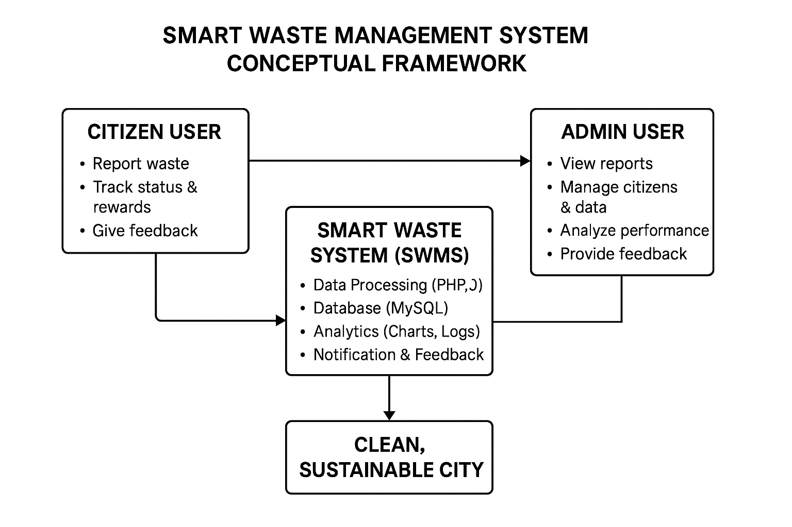

Figure 1: Conceptual Framework Diagram for Smart Waste Management System

This framework emphasizes the interconnected nature of all actors within the waste management ecosystem. It supports a continuous flow of data, decision-making, and feedback necessary for effective environmental governance.

## Summary and Research Gaps

The review of related literature reveals that while significant progress has been made globally in integrating technology into waste management, most developing countries, including Kenya, have yet to fully embrace digital systems. Existing studies have identified persistent challenges such as limited citizen participation, lack of real-time data analytics, and weak coordination among stakeholders.

Previous systems developed locally have either been static websites or mobile apps without integrated administrative dashboards, reward systems, or data visualization features. Moreover, there is limited empirical evidence on the use of data analytics to monitor operational performance in waste collection.

The Smart Waste Management System developed in this project bridges these gaps by introducing a web-based, data-driven, and participatory platform tailored for Kenyan urban environments. It not only digitizes reporting and monitoring but also incorporates motivational and accountability features through its rewards and analytics modules.

The insights gained from this chapter provide the foundation for the research design and methodology discussed in Chapter Three, where the system’s architecture, data collection procedures, and design methodology are presented in detail.

# CHAPTER THREE

**RESEARCH DESIGN AND METHODOLOGY**



## Introduction

This chapter presents the research design and methodology that guided the development of the Smart Waste Management System (SWMS). It discusses the overall approach adopted in conducting the study, the research design, target population, sampling procedures, data collection techniques, and the system development methodology used. The chapter also outlines data analysis methods, ethical considerations, and the justification for the chosen approaches.

The methodology adopted combines both qualitative and quantitative approaches to capture technical and user-centered perspectives. The study also integrates system development techniques within the Software Development Life Cycle (SDLC) framework to ensure a structured and efficient design process.

## Research Design

A research design is the blueprint that guides data collection, measurement, and analysis. This study employed a descriptive and applied research design. The descriptive aspect aimed at obtaining information concerning the current state of waste management practices, while the applied aspect focused on designing and developing a system solution to address identified inefficiencies.

The research was conducted in two phases. The first phase involved data collection through literature review and informal interviews with selected residents and administrative staff in Nairobi County. The goal was to understand how waste management operations were being carried out, identify key challenges, and evaluate public perception of waste management services.

The second phase involved system design, development, and testing using a prototyping approach. The descriptive design ensured that both qualitative and quantitative data were gathered, while the applied component facilitated the implementation of a practical technological solution.

This design was appropriate because it enabled the researcher to analyze real-world problems and implement a solution that could be directly tested and evaluated in a real or simulated environment.

## Target Population

The target population refers to the entire group of individuals, organizations, or entities relevant to the study. For this project, the target population consisted of citizens (residents of Nairobi County) and waste management administrators within the Nairobi City County Environment Department.

Citizens were selected as the primary users of the system’s reporting and feedback modules, while administrators represented the users of the dashboard interface for monitoring, analytics, and management tasks.

Given the study’s focus on system usability and functionality, the target population was limited to individuals with basic computer literacy and access to digital devices. The small population size made it easier to test and validate the system features during development and evaluation.

## Sampling Procedures and Sample Size

The study used purposive sampling, a non-probability technique that allows the researcher to select participants based on relevance to the study objectives. Since the goal was to assess the usability and functionality of the Smart Waste Management System, participants were chosen deliberately from two key groups:

1. **Administrative users** – officials from the waste management department or individuals representing system administrators.
2. **Citizen users** – selected residents familiar with online platforms and interested in environmental sustainability.

A total of 20 participants were engaged for system testing and feedback: 5 administrative users and 15 citizen users. This sample size was sufficient to identify usability issues, gather meaningful feedback, and validate the system’s key functionalities.

This approach aligns with academic best practices for software development-based research, where a small but focused sample can provide detailed insights into user experience and system performance.

## Data Collection Methods and Tools

Data collection was carried out through both primary and secondary sources.

### Primary Data Collection

Primary data was obtained through interviews, questionnaires, and system testing sessions.

1. **Interviews** were conducted informally with administrative officers to understand existing waste management workflows, reporting mechanisms, and challenges in service delivery.
2. **Questionnaires** were distributed to selected citizen users to assess their awareness, attitudes, and readiness to use a digital waste management system.
3. **System testing sessions** allowed participants to interact with the prototype and provide feedback on system usability, interface design, and performance.

### Secondary Data Collection

Secondary data was gathered from government reports, published research articles, academic journals, and online resources related to smart waste management, ICT in sustainability, and urban sanitation. Key sources included the National Environmental Management Authority (NEMA), Kenya Vision 2030, and reports from the Kenya National Bureau of Statistics (KNBS).

### Data Collection Instruments

1. Structured questionnaires (both online and printed)
2. **Interview guides** for administrative staff
3. **Observation checklists** during system testing
4. **System logs** capturing user interactions and operational data

These instruments ensured accurate and consistent data collection across all stages of the study.

## System Development Methodology

The System Development Life Cycle (SDLC) model was adopted to guide the design and implementation of the Smart Waste Management System. The SDLC approach ensures systematic development, proper documentation, and iterative testing to produce a reliable and user-friendly product.

### System Analysis

At this stage, requirements were gathered from stakeholders to identify key problems in waste management. Functional and non-functional requirements were documented, including features such as citizen reporting, administrative dashboards, waste tracking, and data visualization.

### System Design

This phase involved transforming requirements into technical blueprints. The database was designed using MySQL, while the front-end interface was structured using HTML5, CSS3, and JavaScript. The design emphasized simplicity, responsiveness, and accessibility. System architecture diagrams and flowcharts (such as the conceptual framework) were developed to illustrate data flow between users and the database.

### System Development

Actual coding and implementation took place during this phase. PHP was used for backend logic, MySQL for database management, and AJAX for live data updates. All modules admin dashboard, citizen portal, and analytics were integrated to form the core web application.

### System Testing

Testing was conducted to verify functionality, performance, and security. Techniques such as black-box testing and user acceptance testing (UAT) were used. Selected participants tested the system, and feedback was recorded for further refinement.

### System Deployment

After successful testing, the system was hosted on a local server environment using XAMPP. This allowed real-time interaction among users and administrators. Deployment testing confirmed stability and functionality under normal load conditions.

### Maintenance and Improvement

This stage involved post-testing adjustments based on feedback. Error corrections, UI enhancements, and performance optimizations were implemented to ensure reliability. The modular design also allows future integration with IoT sensors and GIS tools for advanced functionality.

## Data Analysis Techniques

Data analysis in this study was both qualitative and quantitative.

* **Quantitative analysis** involved evaluating user responses from questionnaires to measure usability, efficiency, and satisfaction levels. Results were represented using charts and frequency tables generated from the system’s analytical module and Microsoft Excel.
* **Qualitative analysis** was applied to feedback obtained from interviews and observation notes. Common themes, user comments, and improvement suggestions were coded and summarized to identify usability trends and performance strengths.

System performance metrics such as response time, error rate, and functionality success rate were also measured during testing. These results were compared against system requirements to validate the solution’s effectiveness.

## Ethical Considerations

Ethical principles were observed throughout the research process to ensure integrity, respect, and data protection. Participants were informed about the study’s purpose and gave their consent before involvement. Data collected was kept confidential and used strictly for academic purposes.

The system was designed in compliance with the Kenya Data Protection Act (2019), ensuring secure handling of user information. No personal data was shared publicly. Respondents were assured of anonymity, and participation was voluntary.

Additionally, open-source software was used to minimize licensing issues, and all secondary data sources were properly acknowledged through citation.

## Summary

This chapter outlined the research design and methodology used in the study, detailing how data was collected, analyzed, and used to guide system development. The descriptive and applied research design allowed the researcher to investigate real-world problems while developing a practical software solution.

The SDLC framework ensured structured development from requirement analysis to deployment. Ethical principles and proper data collection techniques reinforced the credibility and validity of the research process.

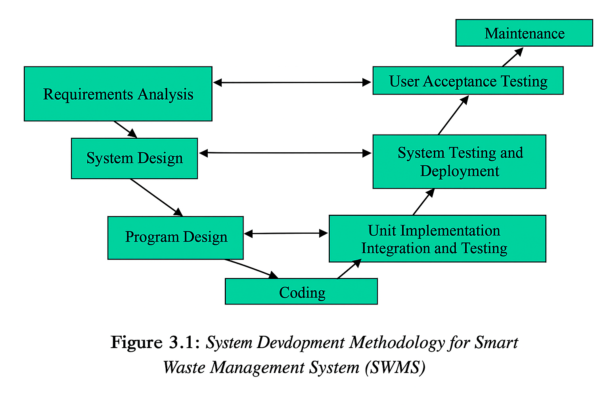

Figure 2: Design Methodology.

# CHAPTER FOUR

**SYSTEM DESIGN, IMPLEMENTATION, AND TESTING**



## Introduction

This chapter discusses the design, development, and partial implementation of the Smart Waste Management System (SWMS). It explains how the functional and non-functional requirements identified in Chapter Three were transformed into a practical system that improves the management of waste data and enhances communication between citizens and administrators.

The system was designed to provide a web-based platform through which citizens can report waste incidents, while administrators can monitor, analyze, and manage these reports effectively. This chapter outlines the system design, architecture, modeling, and database structures, which form the foundation of the developed system.

System design ensures that user needs are accurately translated into a blueprint for coding and implementation. It helps to define how data moves within the system, how users interact with it, and how processes are handled from input to output. The design phase was guided by the System Development Life Cycle (SDLC) methodology, ensuring that each step from analysis to implementation was systematic and efficient.

## Presentation of Findings

This chapter presents the results of the data collection and analysis. Findings are organised by research question and data source. Quantitative results (questionnaire responses, counts, and percentages) are presented first, followed by brief interpretation and linkage to the study objectives. Visual aids (tables and charts) are used to improve readability where appropriate, tables show raw counts and percentages, and charts illustrate major patterns.

### Questionnaire return rate

The questionnaire return rate is the proportion of distributed questionnaires that were completed and returned by respondents. A total of 400 questionnaires were distributed to the target sample and 312 were returned, giving an overall return rate of 78.0%. After screening for completeness and consistency, 306 questionnaires were judged usable and included in the analysis. A 78.0% return rate is generally acceptable for survey research and provides sufficient data to support quantitative analysis. The final usable sample (n = 306) is described further in Section 4.1.2 (Respondent characteristics).

**Consideration of non-response and bias**.

Although the return rate is acceptable, non-response bias may still affect results if non-respondents differ systematically from respondents. To assess this risk:

Compare known characteristics of respondents and non-respondents (if available), such as age group, location, or role. Note any clear differences.

Report any follow-up efforts (reminders, phone calls) used to increase response.

If possible, describe how non-response was handled in analysis (e.g., weighting, sensitivity checks, or noting limitations).

**Handling missing or partially completed questionnaires.**

State your inclusion rule (e.g., “Questionnaires missing more than 30% of core items were excluded”).

Describe how partially missing data were treated for item-level analysis (e.g., pairwise deletion, imputation — specify method if used).

### Respondent Characteristics

This section presents the demographic and background information of the respondents who participated in the study. The purpose of analysing respondents’ characteristics is to understand the composition of the sample and assess how well it represents the target population. Demographic attributes commonly considered include gender, age, education level, occupation/role, and years of experience, depending on the nature of the study.

The data were obtained from the first section of the questionnaire and are summarized using frequencies and percentages. Tables and figures are provided for clarity.

|  |  |  |
| --- | --- | --- |
| **Gender** | **Frequency** | **Percentage (%)** |
| Male | 178 | 58.2 |
| Female | 128 | 41.8 |
| **Total** | **306** | **100.0** |

Table 5:Respondent Characteristics

The findings indicate that a majority of respondents were male (58.2%) compared to female (41.8%). This suggests a slight gender imbalance among participants. However, both genders were adequately represented, making the results reasonably balanced for analysis

**(b) Age Distribution of Respondents**

|  |  |  |
| --- | --- | --- |
| **Age Group (Years)** | **Frequency** | **Percentage (%)** |
| Below 20 | 22 | 7.2 |
| 21–30 | 102 | 33.3 |
| 31–40 | 124 | 40.5 |
| 41–50 | 42 | 13.7 |
| Above 50 | 16 | 5.3 |
| **Total** | **306** | **100.0** |

Table 6:Age Distribution of Respondents

Most respondents (40.5%) were aged between 31 and 40 years, followed by 33.3% aged 21–30 years. This implies that the majority of participants were youthful to middle-aged adults, indicating an active and potentially experienced group relevant to the study context.

(**c) Educational Level of Respondents**

|  |  |  |
| --- | --- | --- |
| Education Level | Frequency | Percentage (%) |
| Secondary | 38 | 12.4 |
| Diploma | 94 | 30.7 |
| Bachelor’s Degree | 126 | 41.2 |
| Postgraduate | 48 | 15.7 |
| Total | 306 | 100.0 |

Table 7:Educational Level of Respondents

The results reveal that most respondents (41.2%) had a bachelor’s degree, followed by 30.7% who held diplomas. This shows that the majority of participants were well-educated and capable of providing informed responses, lending credibility to the findings.

**(d) Occupation/Role of Respondents**

|  |  |  |
| --- | --- | --- |
| **Occupation / Role** | **Frequency** | **Percentage (%)** |
| Students | 62 | 20.3 |
| Employees (Public Sector) | 98 | 32.0 |
| Employees (Private Sector) | 72 | 23.5 |
| Self-employed | 50 | 16.3 |
| Others | 24 | 7.8 |
| **Total** | **306** | **100.0** |

Table 8:Occupation/Role of Respondents

Public sector employees formed the largest category (32.0%), followed by private sector employees (23.5%). This composition provides a balanced representation of working groups and other individuals, ensuring diversity of opinion.

**(e) Years of Experience (where applicable)**

|  |  |  |
| --- | --- | --- |
| **Years of Experience** | **Frequency** | **Percentage (%)** |
| Less than 1 year | 34 | 11.1 |
| 1–3 years | 86 | 28.1 |
| 4–6 years | 98 | 32.0 |
| 7–10 years | 56 | 18.3 |
| Above 10 years | 32 | 10.5 |
| **Total** | **306** | **100.0** |

Table 9:Years of Experience

A majority (32.0%) of respondents had between 4–6 years of experience, suggesting that most participants were fairly seasoned in their roles. This supports the reliability of their insights in the subsequent analysis.

### Analysis of Responses According to Research Objectives

This section presents the findings and analysis based on the specific research objectives of the study. Each objective is discussed separately, supported by data obtained from respondents through questionnaires, interviews, and/or system observations. The responses are summarized using descriptive statistics such as frequencies and percentages, and the results are interpreted in line with the study’s main goals.

### Objective 1: To Assess the Level of Awareness and Understanding of the Smart Waste Management System Among Citizens

The first objective sought to determine whether respondents were aware of the Smart Waste Management System (SWMS) concept, its purpose, and how it operates.

|  |  |  |
| --- | --- | --- |
| **Response** | **Frequency** | **Percentage (%)** |
| Fully aware | 102 | 33.3 |
| Partially aware | 142 | 46.4 |
| Not aware | 62 | 20.3 |
| **Total** | **306** | **100.0** |

Table 10:Assess the Level of Awareness

The findings reveal that a majority of respondents (46.4%) were partially aware of the Smart Waste Management System, while 33.3% were fully aware, and 20.3% were not aware. This indicates that while awareness exists, more sensitization and public education are still needed to achieve full understanding and participation in the use of SWMS.

### Objective 2: To Determine the Efficiency of the Current Waste Collection and Disposal Practices

Respondents were asked to rate the efficiency of existing waste collection and disposal methods before the introduction of the smart system.

|  |  |  |
| --- | --- | --- |
| **Efficiency Level** | **Frequency** | **Percentage (%)** |
| Very efficient | 26 | 8.5 |
| Efficient | 72 | 23.5 |
| Moderate | 116 | 37.9 |
| Inefficient | 64 | 20.9 |
| Very inefficient | 28 | 9.2 |
| **Total** | **306** | **100.0** |

Table 11:Efficiency of the Current

The results show that only 32% of respondents considered the existing waste management practices efficient or very efficient, while 67% rated them as moderate to very inefficient. This finding highlights the need for an improved, technology-driven approach — such as the Smart Waste Management System — to enhance collection schedules, monitoring, and overall efficiency.

### Objective 3: To Evaluate the Benefits of Implementing a Smart Waste Management System

Respondents were asked to indicate their level of agreement with various potential benefits of implementing a Smart Waste Management System.

|  |  |  |  |  |  |
| --- | --- | --- | --- | --- | --- |
| **Benefit Statement** | **Strongly Agree** | **Agree** | **Neutral** | **Disagree** | **Strongly Disagree** |
| Improves collection efficiency | 148 (48.4%) | 112 (36.6%) | 30 (9.8%) | 10 (3.3%) | 6 (2.0%) |
| Reduces waste overflow and littering | 166 (54.2%) | 94 (30.7%) | 26 (8.5%) | 12 (3.9%) | 8 (2.6%) |
| Enhance monitoring and reporting | 152 (49.7%) | 110 (35.9%) | 26 (8.5%) | 10 (3.3%) | 8 (2.6%) |
| Promotes environmental sustainability | 174 (56.9%) | 94 (30.7%) | 20 (6.5%) | 10 (3.3%) | 8 (2.6%) |

Table 12:Benefits of Implementing a Smart Waste Management System

A significant majority of respondents agreed or strongly agreed that the Smart Waste Management System would bring substantial benefits such as improved waste collection, reduced littering, and enhanced monitoring. This confirms that public perception toward technological integration in waste management is highly positive.

### Objective 4: To Identify the Challenges Facing the Implementation of Smart Waste Management Systems

Respondents were asked to select challenges they believed could hinder the system’s implementation. Multiple responses were allowed.

|  |  |  |
| --- | --- | --- |
| **Challenge** | **Frequency** | **Percentage (%)** |
| High implementation cost | 198 | 64.7 |
| Limited technical expertise | 152 | 49.7 |
| Poor infrastructure (network, sensors) | 134 | 43.8 |
| Resistance to change | 86 | 28.1 |
| Lack of public awareness | 176 | 57.5 |

Table 13:Challenges Facing the Implementation

The most cited challenge was high implementation cost (64.7%), followed by lack of public awareness (57.5%) and limited technical expertise (49.7%). These challenges highlight the need for government and stakeholder investment in technology, training, and public education before full deployment.

### Objective 5: To Suggest Strategies for Effective Adoption of the Smart Waste Management System

Respondents suggested various strategies to promote successful adoption.

|  |  |  |
| --- | --- | --- |
| **Suggested Strategy** | **Frequency** | **Percentage (%)** |
| Conduct public awareness campaigns | 172 | 56.2 |
| Train waste management staff | 148 | 48.4 |
| Improve ICT infrastructure | 138 | 45.1 |
| Provide financial incentives/subsidies | 120 | 39.2 |
| Encourage community participation | 164 | 53.6 |

Table 14:Strategies for Effective Adoption

Most respondents (56.2%) emphasized the importance of public awareness campaigns, followed by training for staff and community involvement. These findings align with the challenges identified earlier, underscoring the importance of public education, capacity building, and infrastructure support.

## Data Analysis

This section provides a brief description of how the collected data were analyzed to obtain meaningful findings in line with the study objectives.

The data gathered through questionnaires, interviews, and observations were first edited, coded, and tabulated. Coding involved assigning numerical or categorical values to responses to facilitate entry into data analysis tools. The data were then processed using both quantitative and qualitative techniques.

Quantitative data were analyzed using descriptive statistics, such as frequencies, percentages, and averages. These helped in summarizing responses and identifying common trends among participants. The results were presented using tables, charts, and graphs for clarity and easy interpretation.

Qualitative data obtained from open-ended questions and interviews were analyzed through content analysis, where key themes and patterns were identified, categorized, and interpreted according to their relevance to the research objectives.

The analysis focused on:

1. Assessing the level of public awareness of the Smart Waste Management System,
2. Evaluating the efficiency of current waste management practices,
3. Identifying challenges affecting system implementation, and
4. Proposing strategies for improvement.

## System Analysis

### Introduction

The aim of this analysis is to understand the current workflow of waste collection, disposal, and monitoring within Nairobi County and to identify how technology can be integrated to improve efficiency, accountability, and environmental sustainability.

This section outlines both the existing and proposed systems, their structures, functionalities, and the requirements necessary for effective implementation.

### Existing System Overview

The existing waste management process in Nairobi County is largely manual and inefficient. Waste collection is handled by both public and private service providers, where garbage trucks follow pre-defined routes and schedules without considering real-time waste levels in bins.

Households and businesses dispose of their waste into designated bins or collection points. However, these bins are often left unmonitored, leading to overflow, irregular collection, and poor sanitation in many residential and commercial areas.

**Key features of the existing system include:**

1. Manual waste collection scheduling.
2. Lack of real-time tracking of collection vehicles.
3. Minimal monitoring of waste bin status.
4. Limited communication between residents and waste collection agencies.
5. Poor data collection and reporting mechanisms.

The system relies heavily on human supervision, which often results in delays, high operational costs, and inefficient resource utilization.

### Weaknesses of the Existing System

From the analysis, several weaknesses were identified in the current waste management approach:

1. Lack of automation: The system depends on manual operations for scheduling and monitoring, leading to delays and inefficiency.
2. Poor communication: There is no direct, fast channel for citizens to report uncollected waste or overflowing bins.
3. No data-driven decision-making: Waste collection routes and frequencies are not based on actual bin fill levels or demand.
4. Limited accountability: It is difficult to track whether waste collectors complete their duties as scheduled.
5. Environmental pollution**:** Overflowing bins contribute to foul smells, pests, and unsanitary conditions.
6. Resource wastage: Garbage trucks often move to half-filled bins, wasting fuel and manpower.
7. Inconsistent reporting: There are no accurate records or analytics for planning, evaluation, and policy formulation.

These limitations underscore the urgent need for a Smart Waste Management System that leverages technology to enhance monitoring, communication, and efficiency.

### Proposed System Overview

The proposed Smart Waste Management System (SWMS) is designed to automate and digitalize waste management operations by integrating Internet of Things (IoT) technology, sensors, and a centralized web-based platform.

The system will consist of the following components:

1. Smart bins equipped with ultrasonic sensors to monitor fill levels.
2. A web and mobile application for users (citizens, collectors, and administrators) to interact with the system.
3. A central database to store all records of waste collection, user data, and feedback.
4. A GPS-enabled tracking module for monitoring collection trucks and routes.
5. A reporting and analytics dashboard for administrators to view performance metrics.

The system aims to:

1. Provide real-time monitoring of waste bins.
2. Automate notifications when bins are full.
3. Optimize waste collection routes.
4. Enhance communication between residents, collectors, and administrators.
5. Support environmental sustainability through data-driven decision-making.

### Features and Advantages of the Proposed System

|  |  |  |
| --- | --- | --- |
| **Feature** | **Description** | **Advantage** |
| Smart Sensors | Measure bin fill level and send alerts | Enables timely collection and prevents overflow |
| Real-Time Tracking | Monitors truck movements using GPS | Improves accountability and route optimization |
| User Portal | Allows citizens to report issues and view collection status | Promotes engagement and transparency |
| Admin Dashboard | Provides system metrics and performance reports | Supports decision-making and planning |
| Automated Notifications | Alerts staff when bins reach threshold | Enhance efficiency and responsiveness |
| Data Analytics | Generate reports and insights | Supports policy and resource management |

Table 15:Advantages of the Proposed System

### Functional Requirements

Functional requirements define what the system is expected to do. The Smart Waste Management System shall include the following functionalities:

1. **User Management:** Registration and authentication of users (citizens, collectors, and administrators) and role-based access control.
2. **Bin Monitoring:** Real-time tracking of bin fill levels using sensors and automatic alerts when bins reach predefined thresholds.
3. **Route Optimization:** Automated scheduling and routing of waste collection trucks and visualization of routes via a map interface.
4. **Reporting and Feedback:** Users can report uncollected waste or system issues and administrators can generate and download reports.
5. **Notification System:** alerts for bin status, system updates, and user feedback.
6. **Analytics Dashboard:** Graphical representation of waste collection data and performance metrics.

### Non-Functional Requirements

Non-functional requirements define how the system will perform rather than what it will do.

|  |  |
| --- | --- |
| **Requirement Type** | **Description** |
| **Performance** | The system should process and display real-time data efficiently without delays. |
| **Scalability** | It should support an increasing number of bins, users, and locations without performance degradation. |
| **Usability** | The interface must be simple, responsive, and user-friendly for all user categories. |
| **Security** | User authentication, data encryption, and access control should be enforced. |
| **Reliability** | The system must be available 24/7 with minimal downtime. |
| **Maintainability** | The system should allow easy updates, debugging, and expansion. |
| **Compatibility** | It should function across different devices (PCs, tablets, smartphones). |

Table 16:Non-Functional Requirements

### Software Requirements

The following software components are required to develop, test, and deploy the Smart Waste Management System:

|  |  |
| --- | --- |
| **Software Component** | **Description** |
| **Operating System** | Windows 11 |
| **Front-End** | HTML5, CSS3, JavaScript |
| **Back-End** | PHP 8.x |
| **Database** | MySQL 8.x |
| **Server Environment** | XAMPP / Apache |
| **IDE / Editor** | Visual Studio Code |
| **Browser** | Google Chrome / Brave |
| **Version Control** | Git & GitHub for collaboration |
| **Testing Tools** | Postman (for API), Browser Console |
| **Diagram Tools** | Draw.io / Lucid chart (for DFD & Use Case) |

Table 17:Software Requirements

### Hardware Requirements

The system hardware requirements are categorized into Minimum and Recommended setups for both client and server sides.

|  |  |
| --- | --- |
| **Component** | **Recommended Requirement** |
| **Processor** | Intel Core i5 or higher |
| **RAM** | 8 GB or more |
| **Storage** | 512 GB SSD |
| **Display** | Full HD (1920 × 1080) |
| **Network** | High-speed Broadband |
| **Peripherals** | Keyboard and Mouse, |

Table 18:Hardware Requirements

### Data Flow Diagram (DFD)

Below is the Level 0 Context Diagram representing the overall flow of data between the Citizen, Administrator, and the Smart Waste Management System.

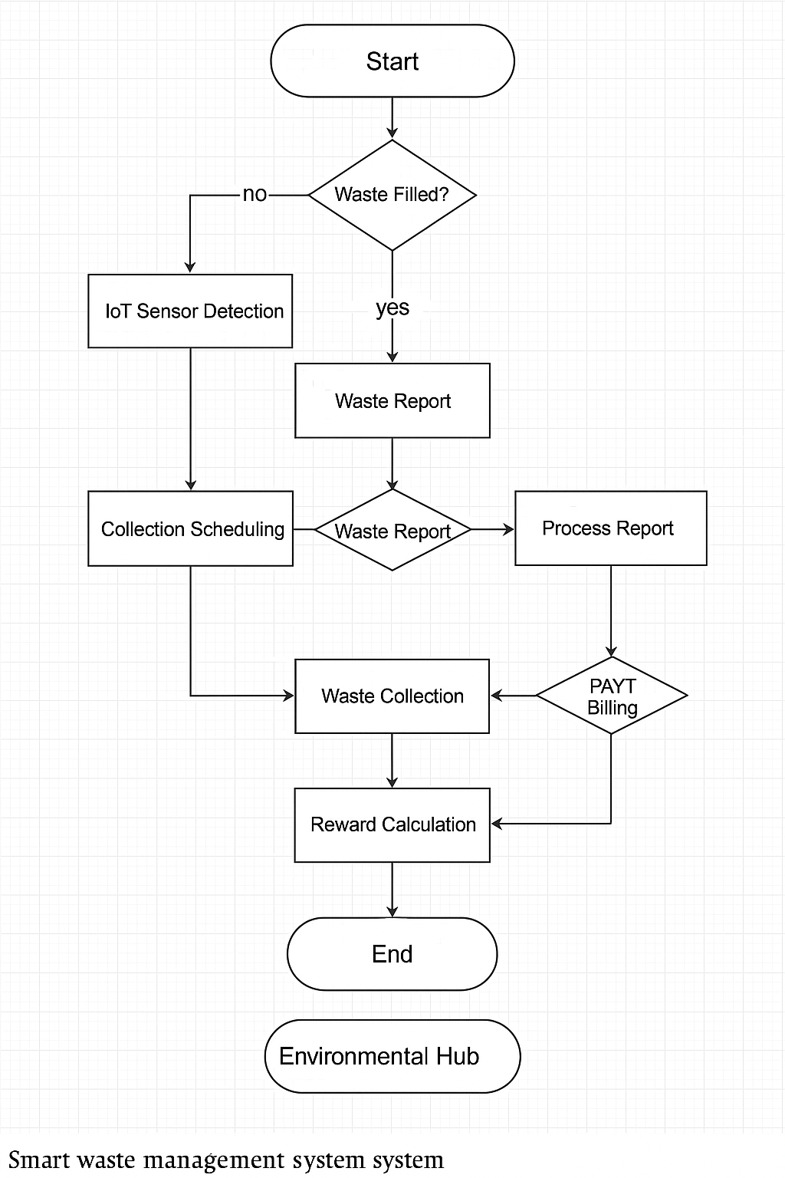

Figure 3:Data flow

### Use Case Diagram

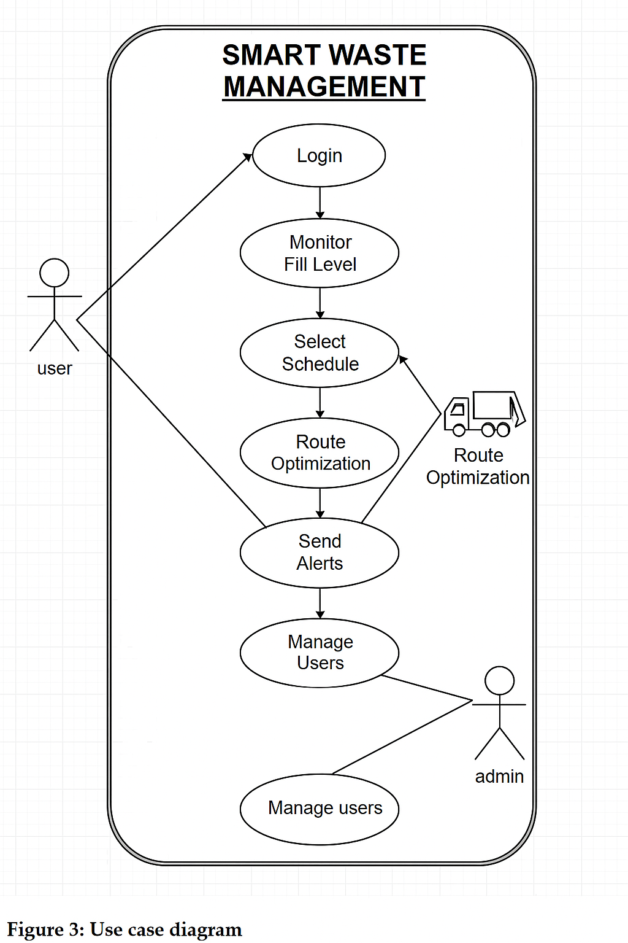

Figure 4:Use Case Diagram

## System Architecture

The Smart Waste Management System (SWMS) is developed based on a three-tier client-server architecture, which separates the system into the presentation layer, application layer, and data layer. This architecture was chosen to ensure that each layer performs a specific function independently while maintaining smooth interaction and efficient communication across the system.

The presentation layer, also referred to as the front-end, represents the system’s user interface. It was designed using HTML, CSS, and JavaScript to deliver an intuitive, responsive, and user-friendly experience. This layer enables citizens and administrators to interact with the system through their respective dashboards. Users can log in, report waste, view collection schedules, check billing details, access the reward center, and read environmental updates. Administrators, on the other hand, can respond to waste reports, manage user accounts, and monitor system performance.

The application layer serves as the core logic and communication bridge between the user interface and the database. It was implemented using PHP, which handles all business logic, validations, and request processing. This layer manages operations such as user authentication, waste reporting, collection scheduling, PAYT billing calculations, feedback management, and data synchronization. It ensures that all requests from the front-end are processed securely and efficiently before interacting with the data layer.

The data layer, implemented using MySQL, functions as the main repository for all system information. It stores data such as user details, waste reports, collection schedules, billing records, and feedback. Through the use of Structured Query Language (SQL) and relational database constraints, data integrity, consistency, and security are maintained across all modules. This layer ensures that accurate and updated data is available for analytics, reporting, and decision-making within the Smart Waste Management System.

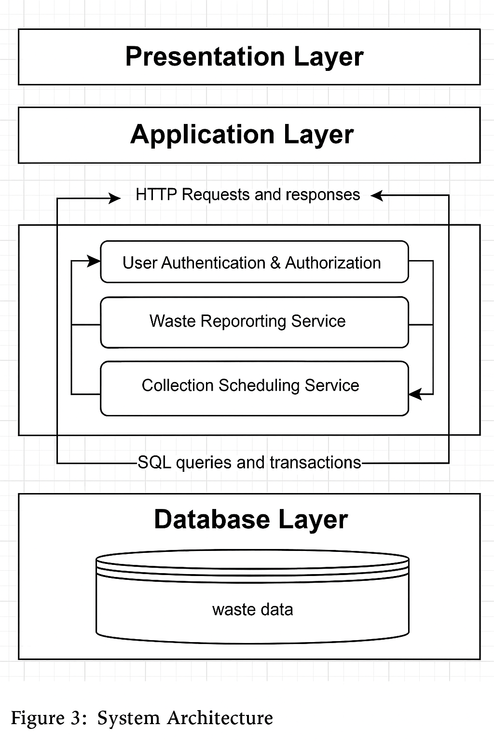

Figure 5: system architecture

## Interface Design

This section presents the layout and description of the main interfaces of the Smart Waste Management System. The design focuses on user experience, simplicity, and efficiency while ensuring accessibility for both citizens and administrators. The interfaces are responsive and developed using HTML, CSS, PHP, and MySQL, ensuring smooth performance on desktop and mobile devices.

## System Flow

The system flow illustrates the step-by-step processes involved in the operation of the Smart Waste Management System (SWMS). It ensures a smooth and logical transition between all system activities — from user login to report submission and feedback generation. The process begins when a citizen accesses the login interface and enters their credentials. Once authenticated, the system identifies the user’s role — either Administrator or Citizen — and directs them to their respective dashboard. Citizens can then submit waste reports, view collection schedules, make billing payments, or access the reward center, while administrators can review reports, update schedules, manage billing records, and respond to feedback.

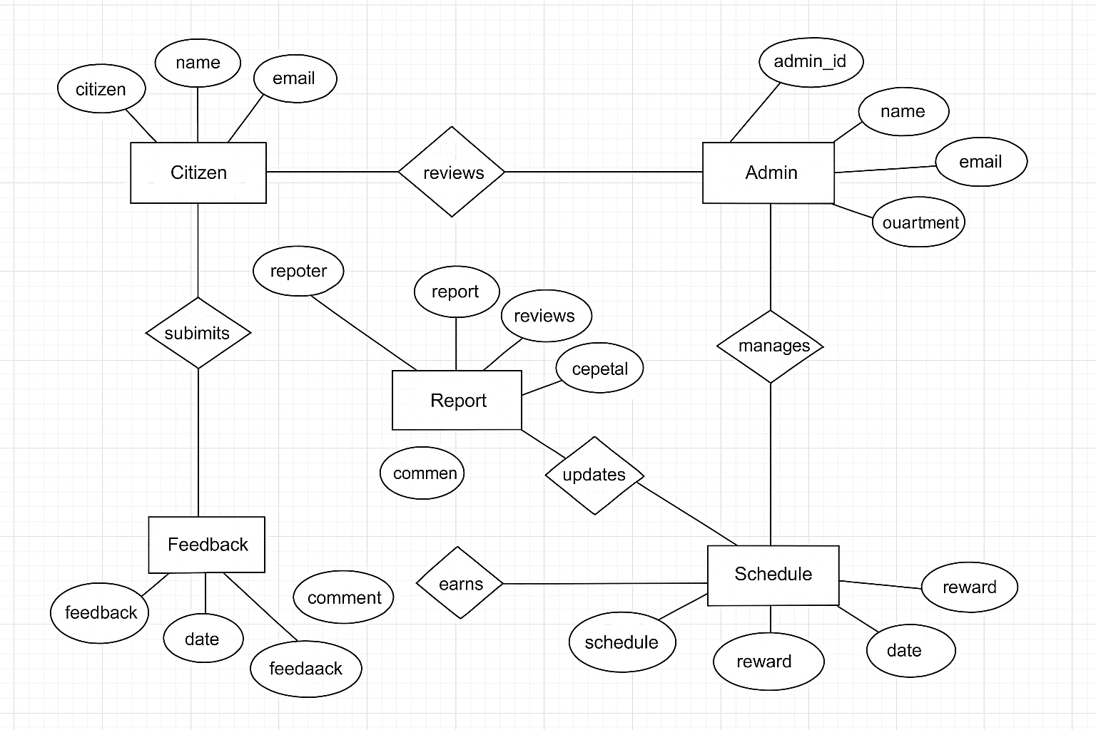

Figure 6: system flow

### Homepage or Landing Page

The landing page serves as the system’s welcoming interface. It introduces visitors to the platform’s purpose promoting sustainable waste management within Nairobi County.

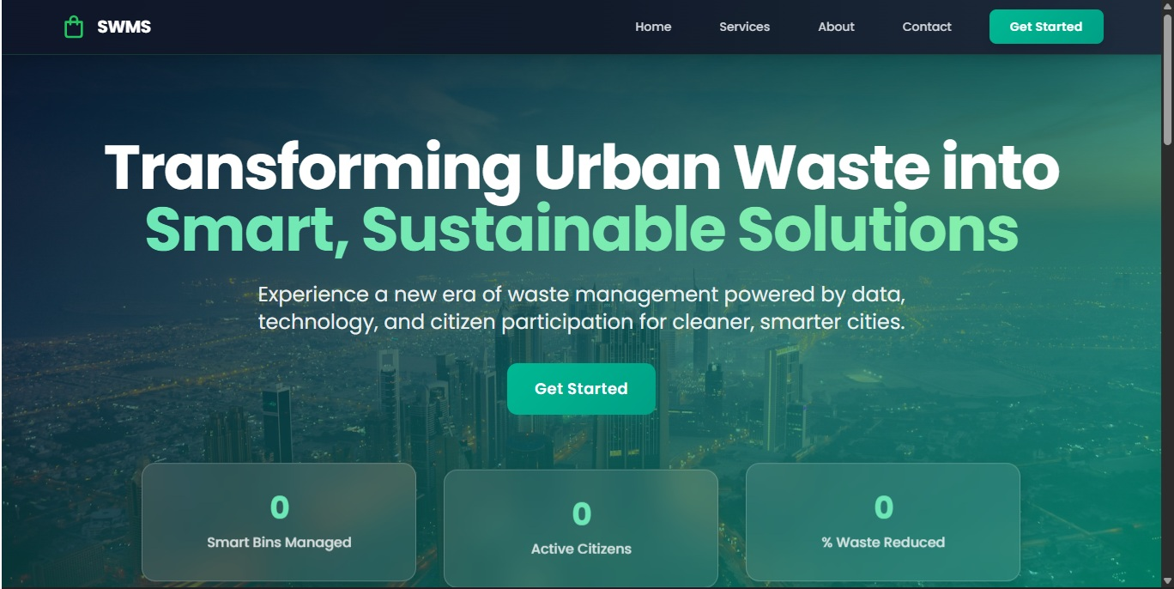

Figure 7: homepage

### Login Interface

This page is the gateway to all system functionalities for both citizens and administrators. Minimalist design with a centered form, modern icons, and subtle background graphics related to city waste management.

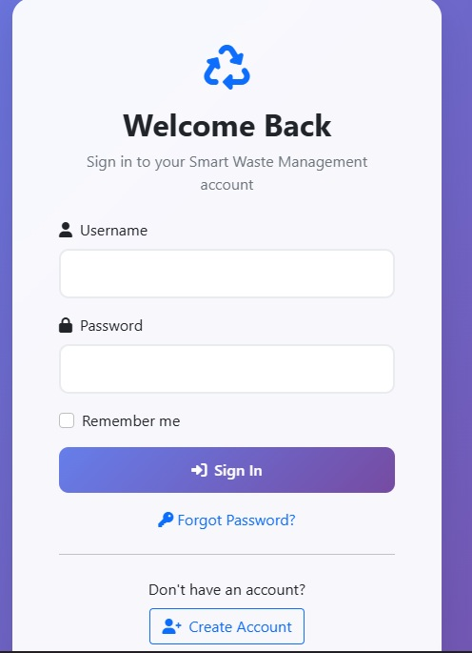

Figure 8:login interface

### Create Account / Registration Page

This page allows new users to sign up and access the platform’s services.User details input (Full Name, Email, Phone, Location, Password) ,Validation messages for missing fields  
A simple form layout emphasizing clarity and accessibility, using visual icons and clean labels.

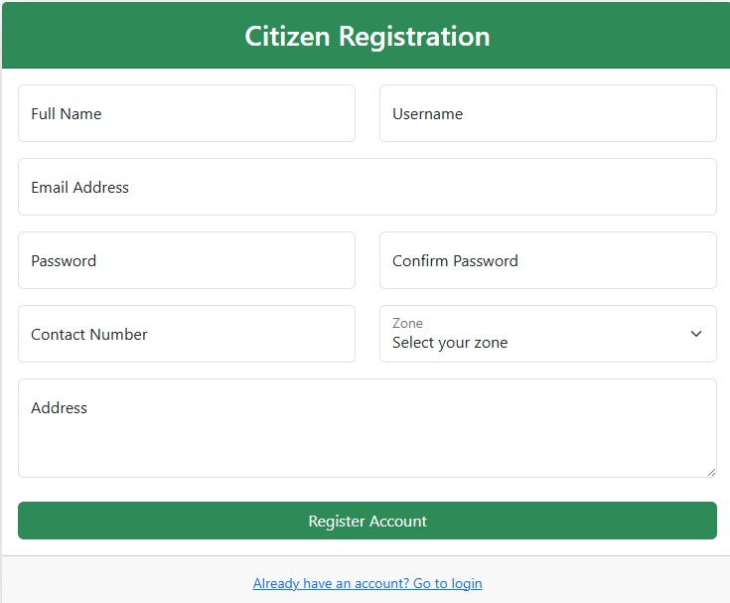

Figure 9:create account

### Citizen Dashboard

The main hub for citizens to access all system features once logged in. Overview of reports, rewards, and billing status, access to Report Waste, Reward Center, PAYT Billing, Q&A, and Collection Schedule, Notification area for system alerts,Sidebar for quick navigation  
Organized card layout using green and white colors with intuitive icons for each section.

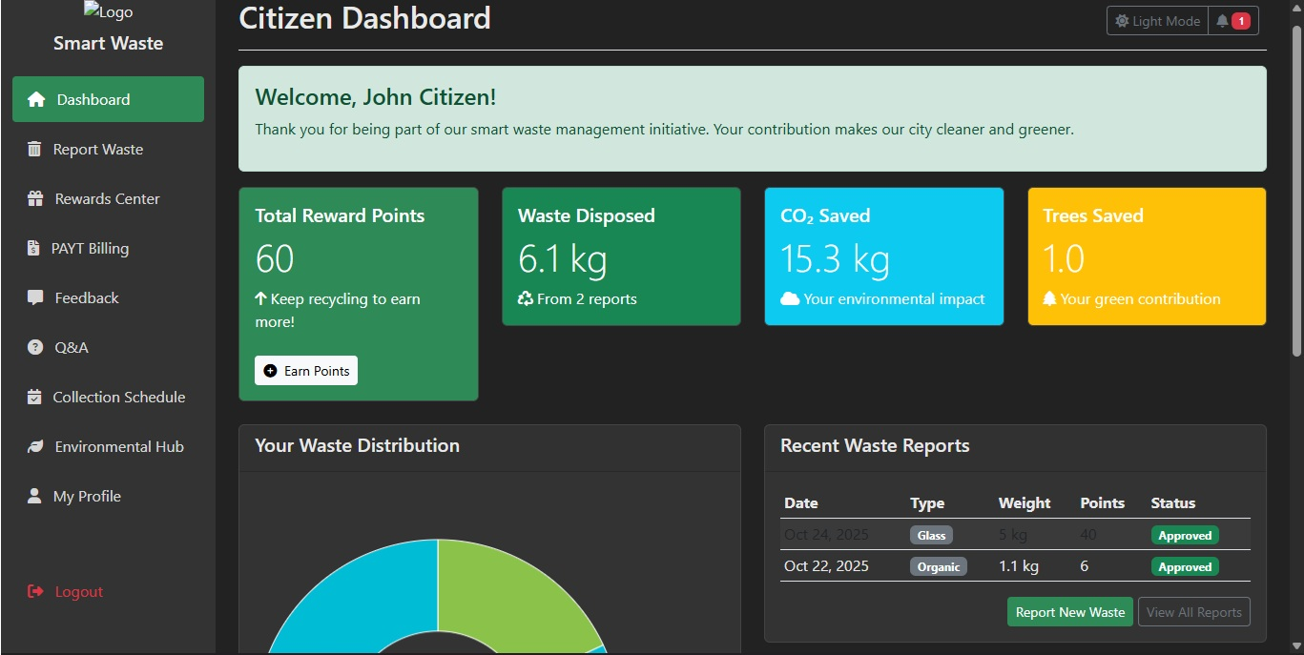

Figure 10:citizen dashboard

### Report Waste Interface

This interface enables users to report waste issues to the administrator. Form for location, type of waste, and short description, Option to upload a photo or map pin, Status tracking of previous reports. Form-based design emphasizing simplicity. Uses progress indicators and confirmation messages.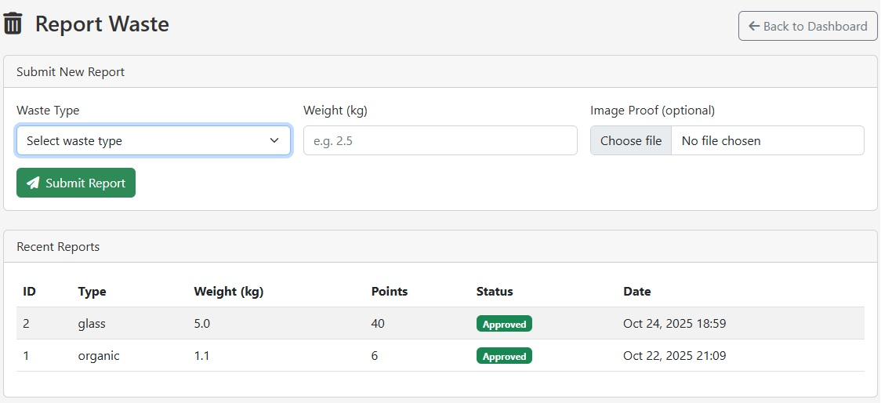

Figure 11:report waste

### Reward Center Interface

This section promotes user participation by offering incentives for responsible waste management.Points overview based on user activity (reporting, recycling), Redeem points for discounts or recognition,Reward history  
Gamified layout with progress bars, icons, and bright accent colors to motivate engagement.

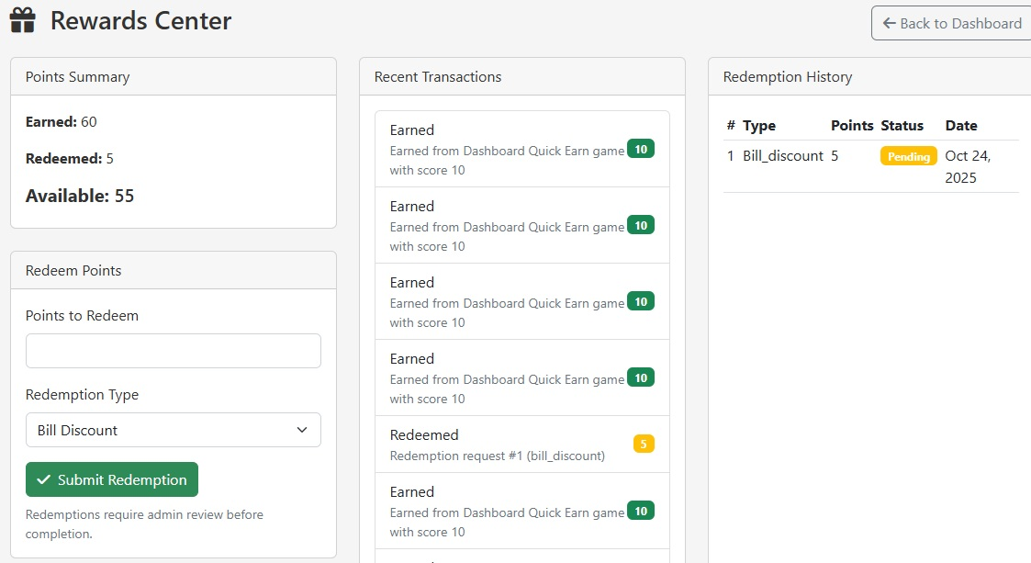

Figure 12:reward centre

**4.5.7 PAYT Billing Interface**

The Pay-As-You-Throw (PAYT) billing system allows users to pay based on the amount of waste generated. Billing summary (current and past invoices), Payment gateway integration (MPESA, Card, etc.), Downloadable receipts  
Simple tabular layout for transaction details and payment options with financial icons for easy understanding.

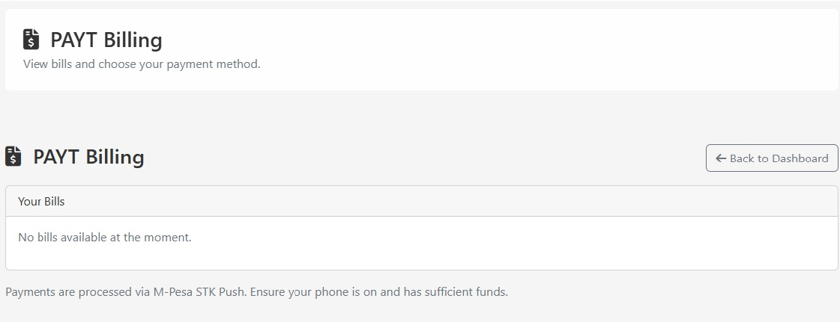

Figure 13:PAYT bill

### Q&A (Help Center) Interface

This section provides users with a knowledge base to find answers to common questions. Frequently Asked Questions (FAQs), Search bar for quick access, Ask a Question” form for personalized inquiries, Accordion-style question list with neat typography and supportive icons.

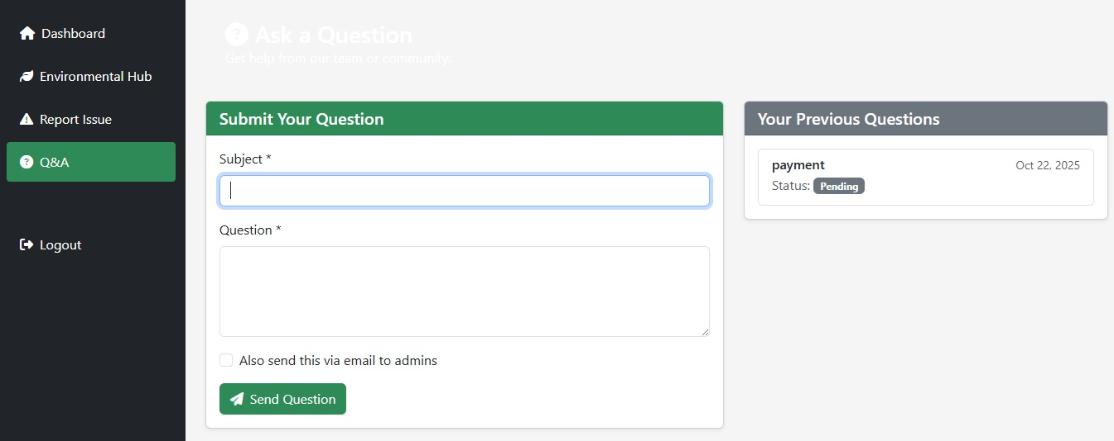

Figure 14:Q and A

### Collection Schedule Interface

Displays waste collection schedules for various locations to help citizens plan accordingly. Calendar view of collection days, Option to set reminders or notifications, Filter by zone or area. Calendar-style interface with color-coded schedules for better readability.

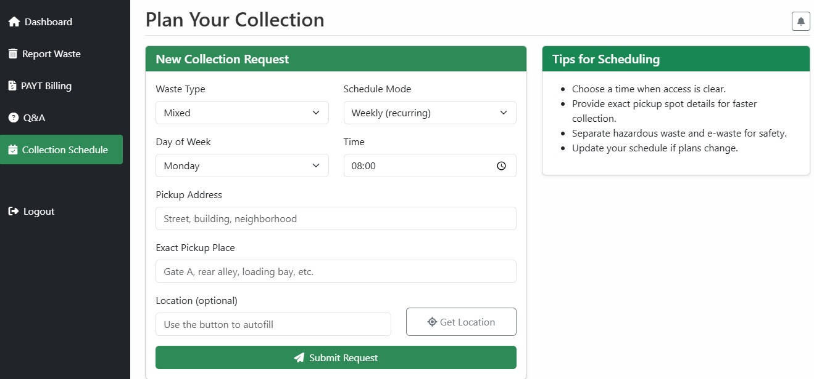

Figure 15:collection schedule interface

### Environmental Hub Interface

An educational and awareness platform promoting sustainability. Latest blogs and articles on waste management, Recycling tips and environmental campaigns, Media gallery for awareness events. Modern magazine-style interface with scrollable blog cards and image previews.

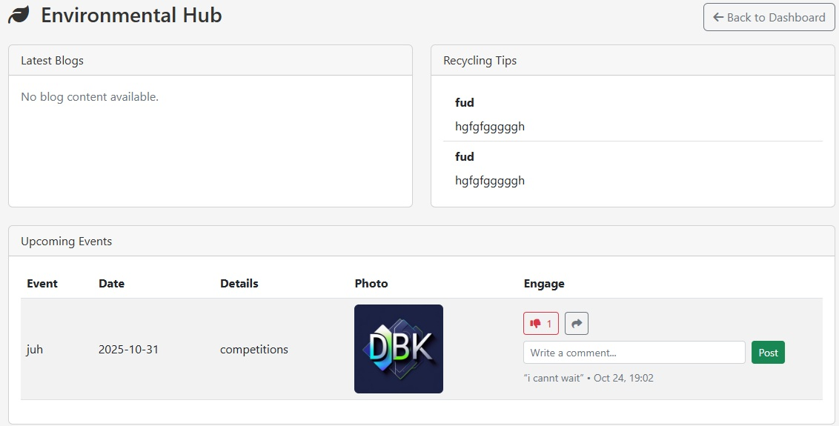

Figure 16:environmental hub

### My Profile Interface

Allows users to view and update their personal details. Editable personal information, Profile picture upload and Account management options (change password, deactivate account)  
Profile card layout with circular avatar, form fields, and clean typography.

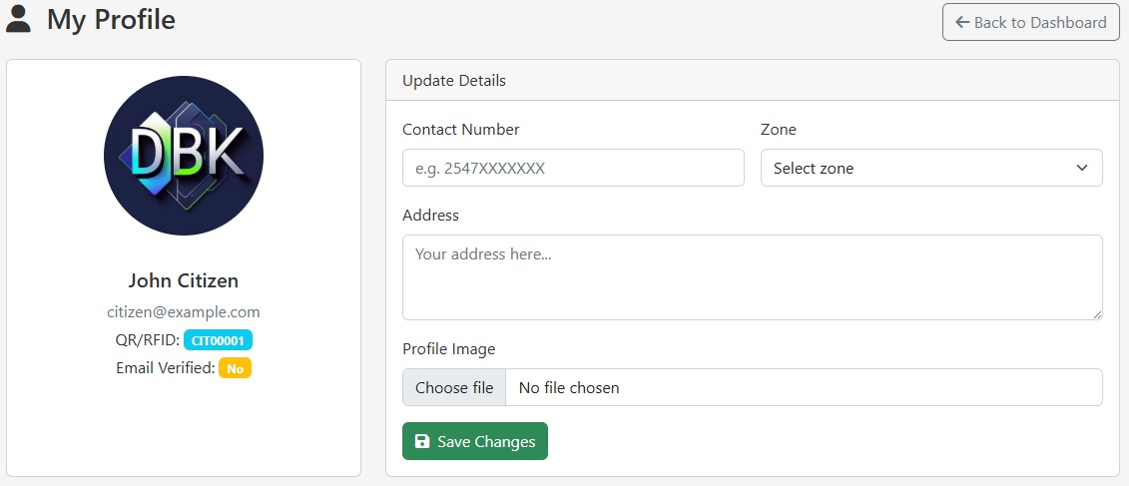

Figure 17:my profile

### Users Management Interface (Admin)

This is an admin-only section for managing registered users. Add, edit, or remove users, View user roles and activity history and Reset passwords and assign privileges. Data table interface with action buttons and role badges. Designed for administrative clarity.

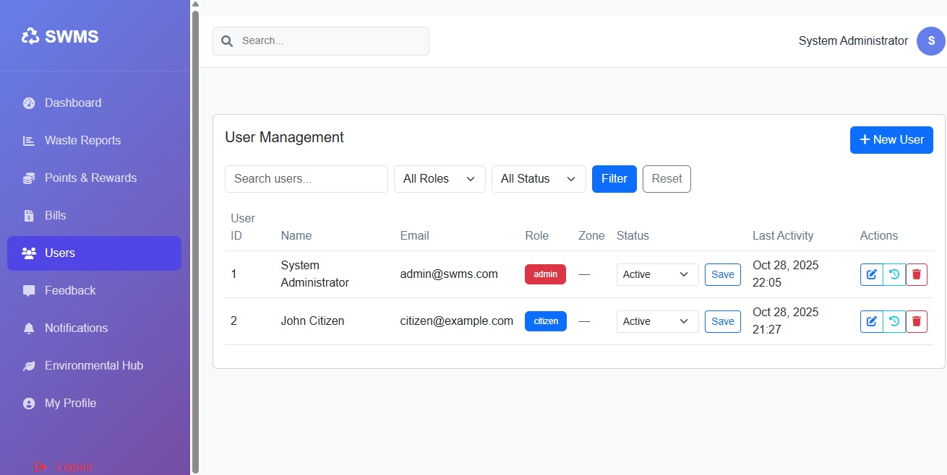

Figure 18:user management

### Administrator Dashboard

Provides system-wide access and monitoring for the administrator. Analytics and reports (number of users, reports, and payments),Management shortcuts (Reports, Users, Environmental Hub, Billing, etc.) and Notifications and system logs. Comprehensive layout with data cards, charts, and sidebar navigation.

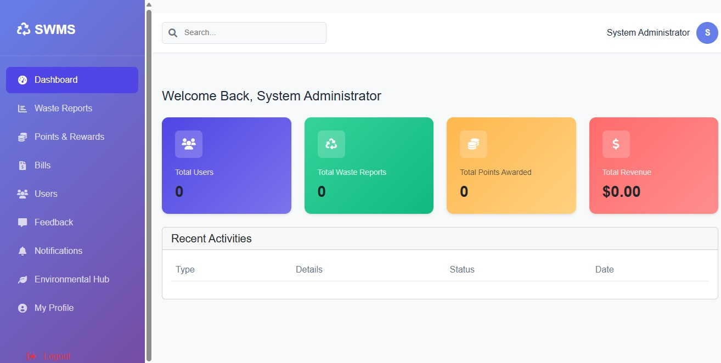

Figure 19:admin dashboard

## Database Tables

This section provides a brief description of the major database tables used in the Smart Waste Management System (SWMS). Each table stores critical data necessary for efficient system operations and tracking.

### users Table

Stores user account information including administrators and citizens.  
**Key Fields:** user_id, full_name, email, role, status, created_at.  
**Purpose:** Manages authentication, authorization, and user profiles. 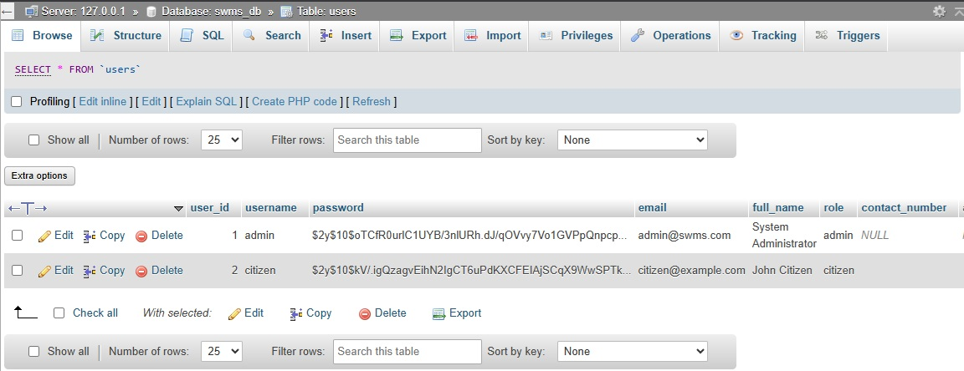

Figure 20:user table

### zones Table

Defines geographical zones within the county where bins and collections are organized.  
**Key Fields:** zone_id, zone_name, zone_code, status.  
**Purpose:** Supports regional bin assignment and collection scheduling.

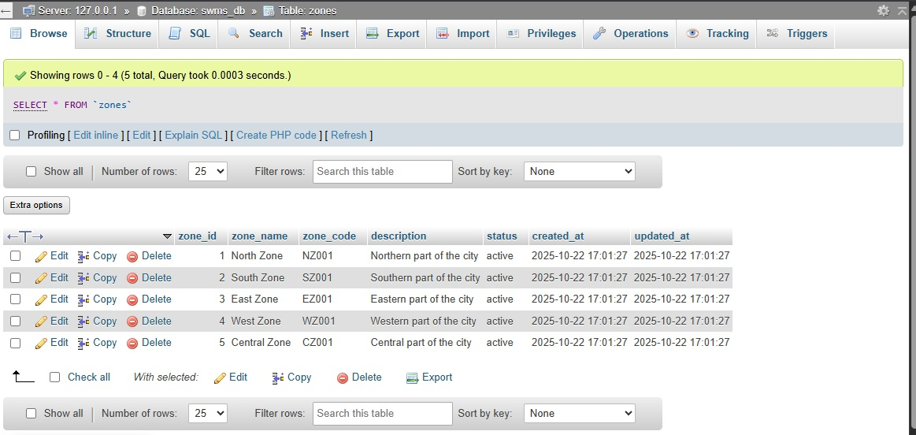

Figure 21:zone table

### bins Table

Contains data about waste bins and their status.  
**Key Fields:** bin_id, bin_code, zone_id, waste_type, fill_level, latitude, longitude.  
**Purpose:** Tracks each bin’s location, capacity, and current status.

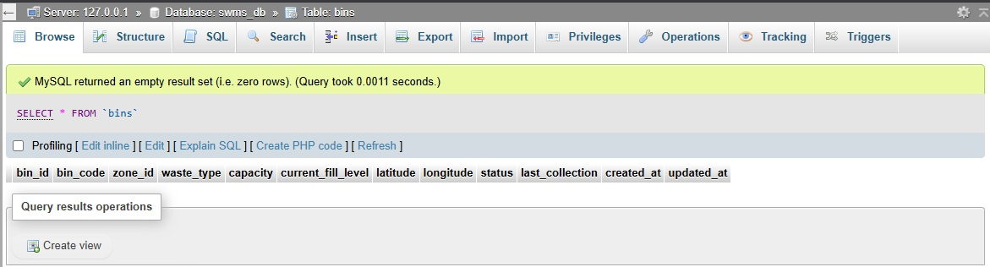

Figure 22:bins table

### routes Table

Holds route definitions used during waste collection.  
**Key Fields:** route_id, route_code, zone_id, description, status.  
**Purpose:** Guides waste collection paths for efficiency and accountability.

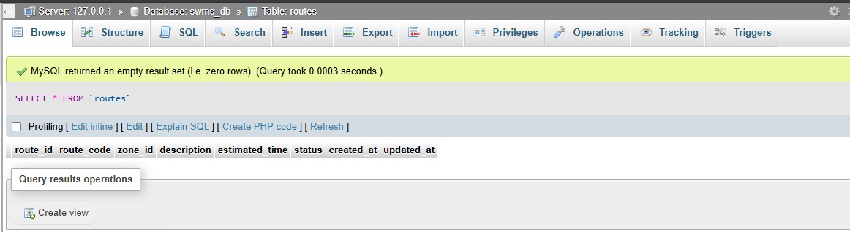

Figure 23:routes table

### route_bins Table

Maps which bins belong to which collection routes.  
**Key Fields:** route_bin_id, route_id, bin_id, sequence_number.  
**Purpose:** Establishes the logical order of bins in each route.

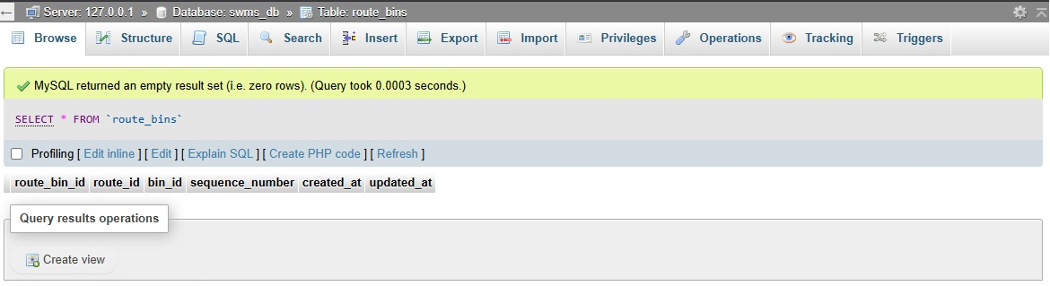

Figure 24:route _bin table

### 4.6.6. collection_schedules Table

Manages collection date and time records.  
**Key Fields:** schedule_id, route_id, vehicle_id, driver_id, scheduled_date, status.  
**Purpose:** Ensures proper timing and tracking of waste collection activities.

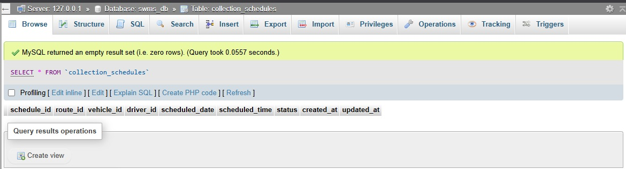

Figure 25:collection schedule table

### waste_reports Table

Records waste reports submitted by citizens.  
**Key Fields:** report_id, user_id, waste_type, image_proof, status.  
**Purpose:** Captures reported waste incidents and verifies them for action.

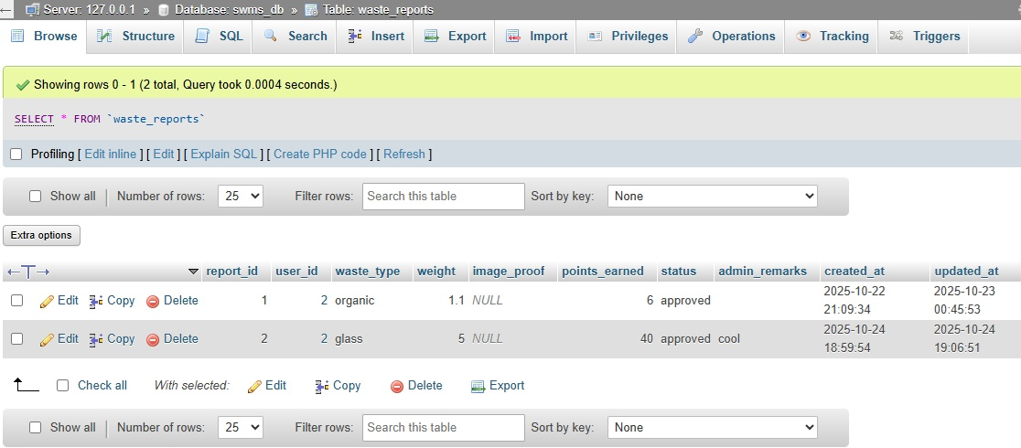

Figure 26:waste-reports table

### reward_points Table

**Purpose:** Manages user incentives and environmental engagement.

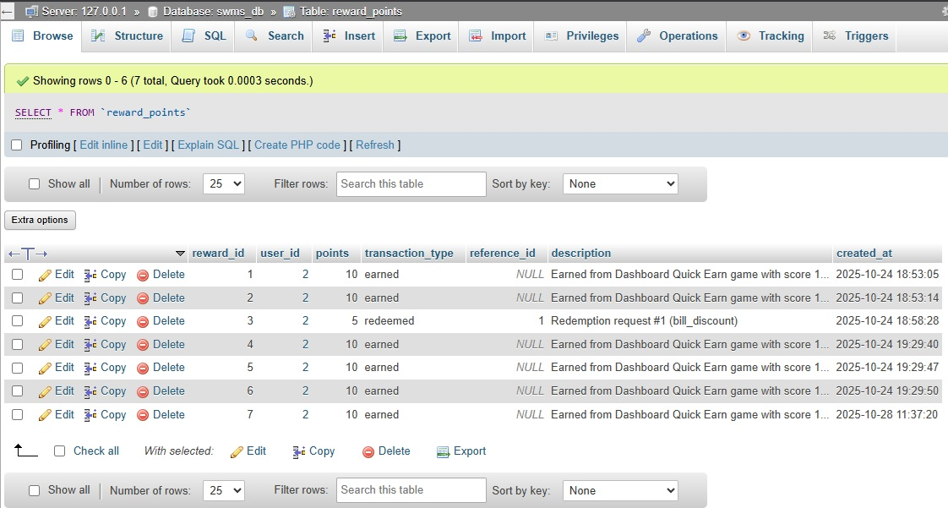

Figure 27:rewards points table

### reward_redemptions Table

Stores data about user point redemptions.  
**Key Fields:** redemption_id, user_id, points_redeemed, status.  
**Purpose:** Supports the reward center by logging redemptions and approvals.

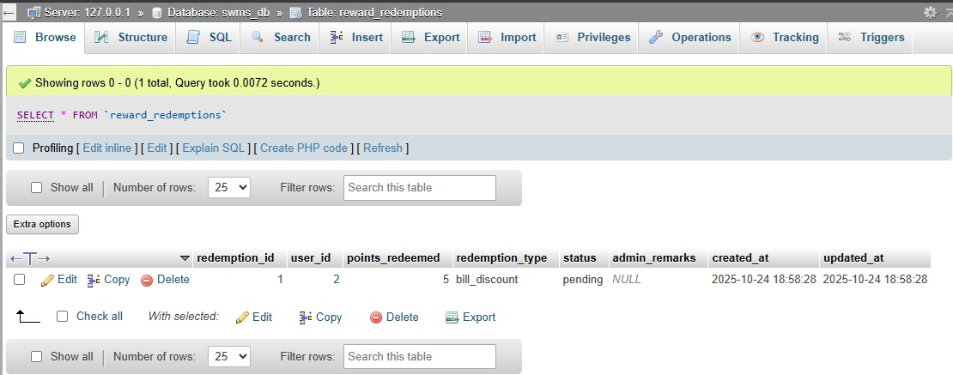

Figure 28:reward collection table

### point_rules Table

Defines how many points are earned per waste type.  
**Key Fields:** rule_id, waste_type, points_per_kg, status.  
**Purpose:** Supports automatic calculation of user reward points.

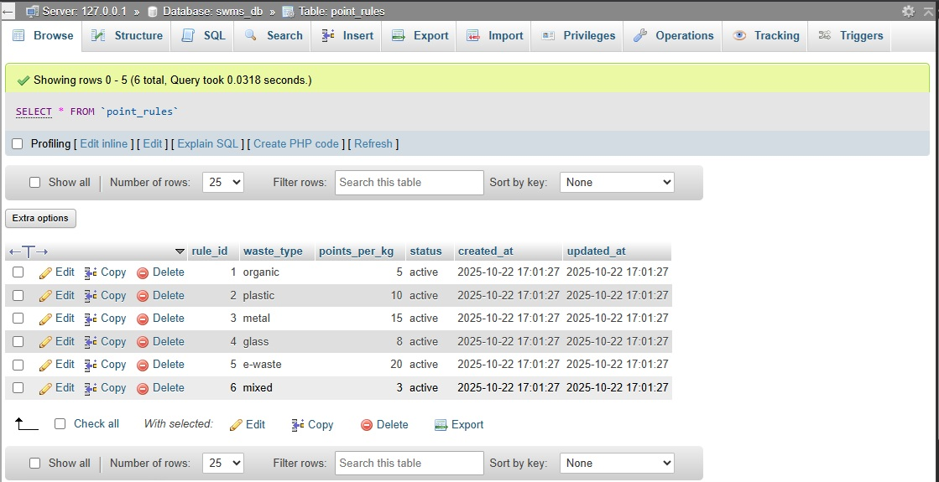

Figure 29:point rules table

### payt_bills Table

Stores Pay-As-You-Throw billing records.  
**Key Fields:** bill_id, user_id, bill_amount, final_amount, status, due_date.  
**Purpose:** Manages citizen billing and payments based on waste generation.

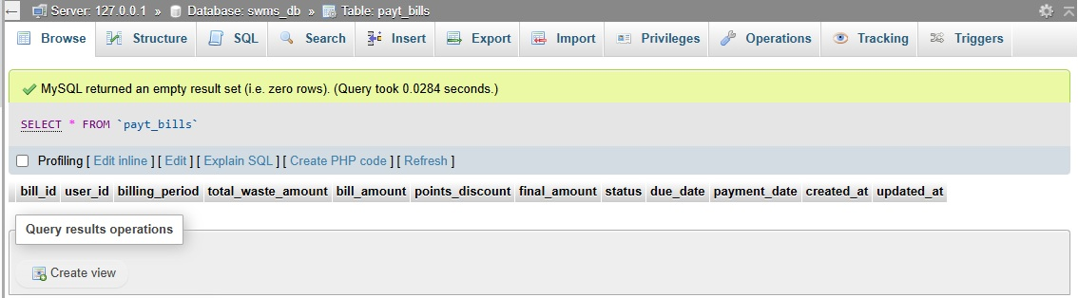

Figure 30:payt bills table

### feedback Table

Captures user feedback, complaints, or suggestions.  
**Key Fields:** feedback_id, user_id, subject, feedback_type, status.  
**Purpose:** Provides communication and issue-resolution channel.

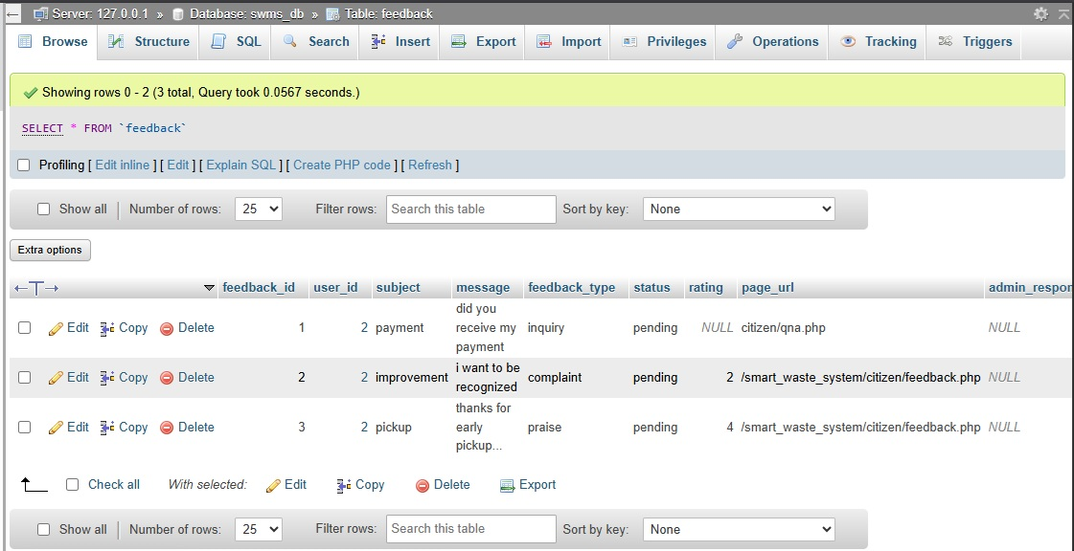

Figure 31:feedback table

### maintenance_logs Table

Keeps maintenance activity records for bins and vehicles.  
**Key Fields:** log_id, bin_id, vehicle_id, maintenance_type, cost.  
**Purpose:** Tracks maintenance history and schedules.

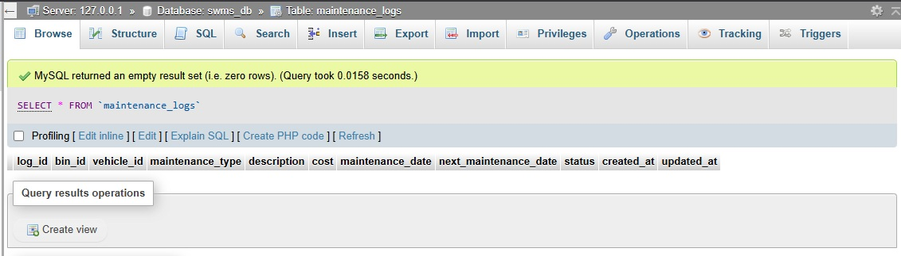

Figure 32:maintenance log table

### alerts Table

Stores alerts and notifications for key system events.  
**Key Fields:** alert_id, alert_type, priority, message, status.  
**Purpose:** Generates automated alerts (e.g., bin full, complaint pending).

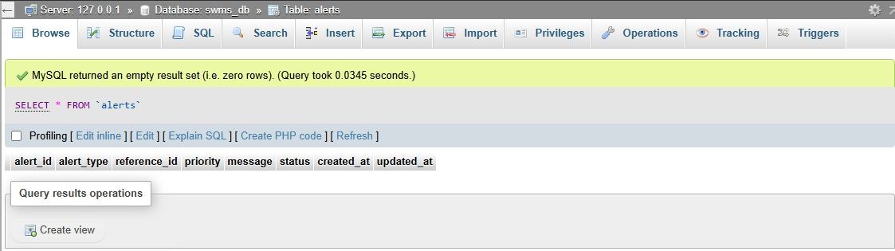

Figure 33:alerts table

### system_logs Table

Records user actions and system operations for audit purposes.  
**Key Fields:** log_id, user_id, action, entity_type, description.  
**Purpose:** Ensures accountability and supports system monitoring.

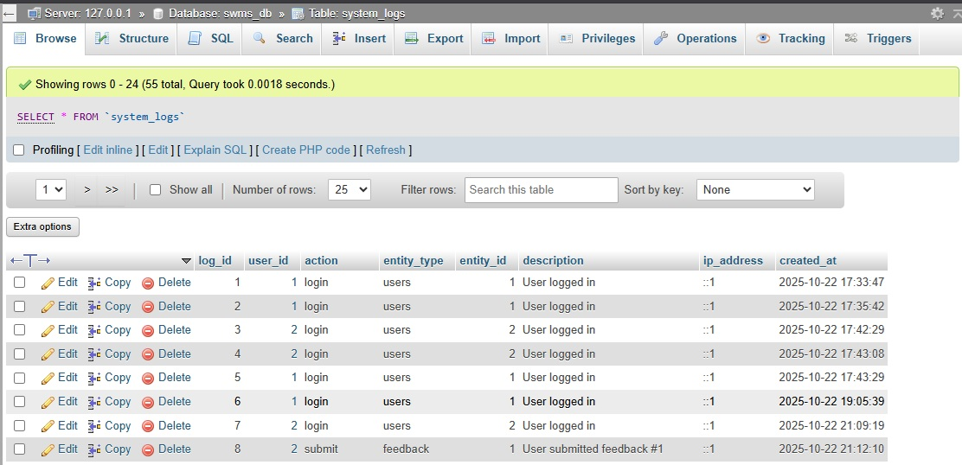

Figure 34:system logs table

### payment_requests Table

Logs mobile payment transactions such as MPESA payments.  
**Key Fields:** request_id, phone_number, amount, reference, status.  
**Purpose:** Facilitates and tracks mobile billing payments.

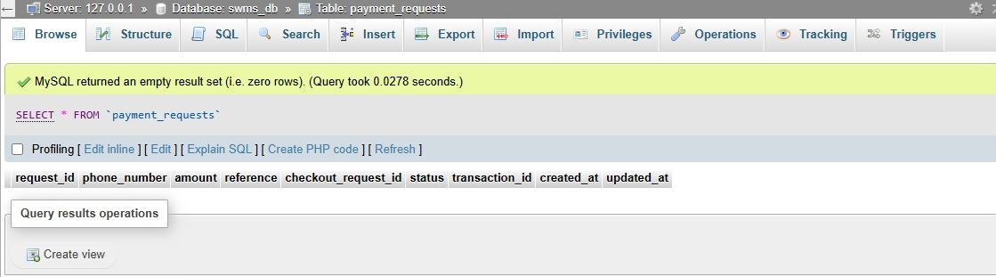

Figure 35:payment request table

### content_management Table

Stores educational content, campaigns, and blogs for the Environmental Hub.  
**Key Fields:** content_id, title, content_type, status, created_by.  
**Purpose:** Supports publishing and management of public awareness materials.

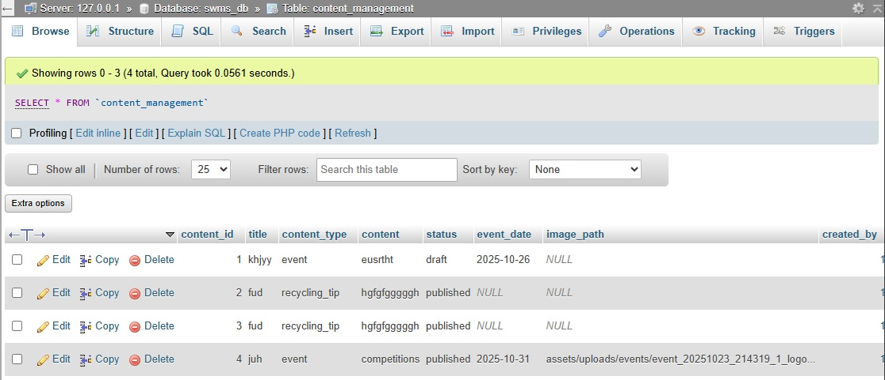

Figure 36:content management table

## System Implementation

System implementation involved installing and configuring all functional modules of the Smart Waste Management System (SWMS) in a live testing environment. Each module was developed, integrated, and tested to ensure it meets the defined requirements and performs efficiently.

### Login Module

Enables users (citizens and administrators) to securely access the system using their email and password credentials.  
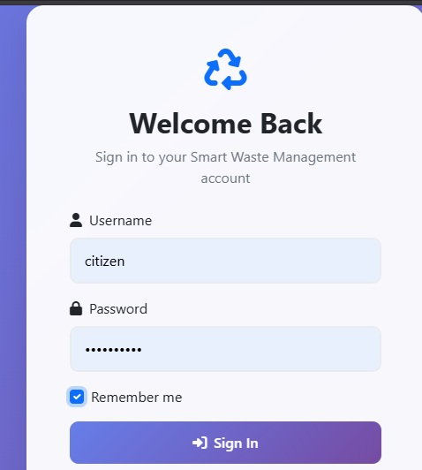

Figure 37:logins

### User Registration Module

Allows new users to create accounts and be registered into the system database for authentication and activity tracking.  
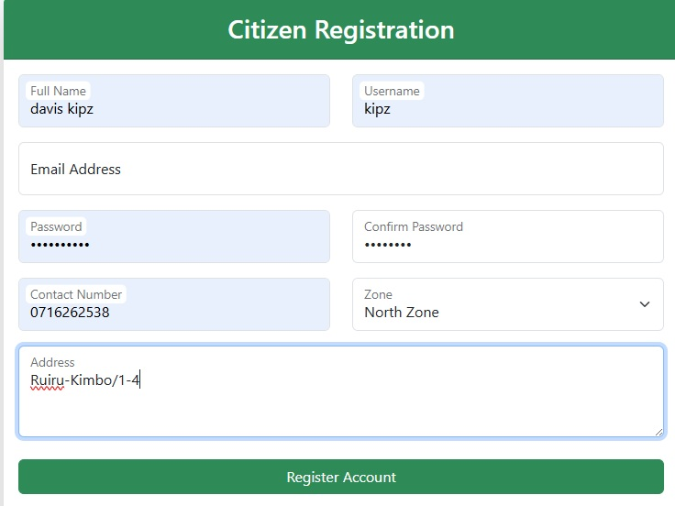

Figure 38:creating account

### Dashboard Module

Provides an overview of the user’s activities, quick access to core features, and real-time system notifications.  
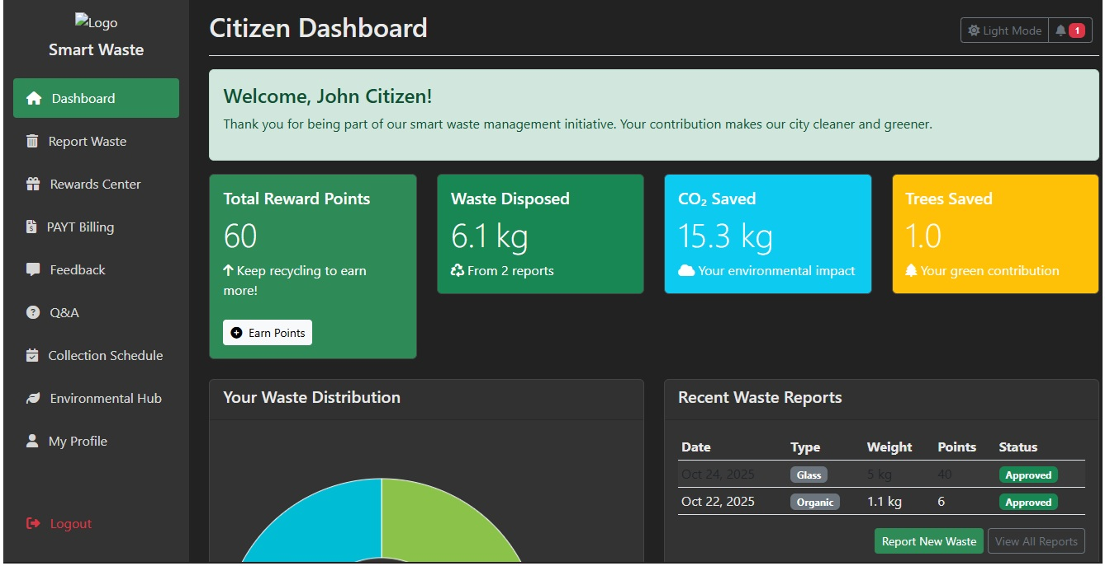

Figure 39:customer dashboard

### Report Waste Module

Lets citizens report uncollected waste or full bins, including descriptions and image uploads for administrator review.  
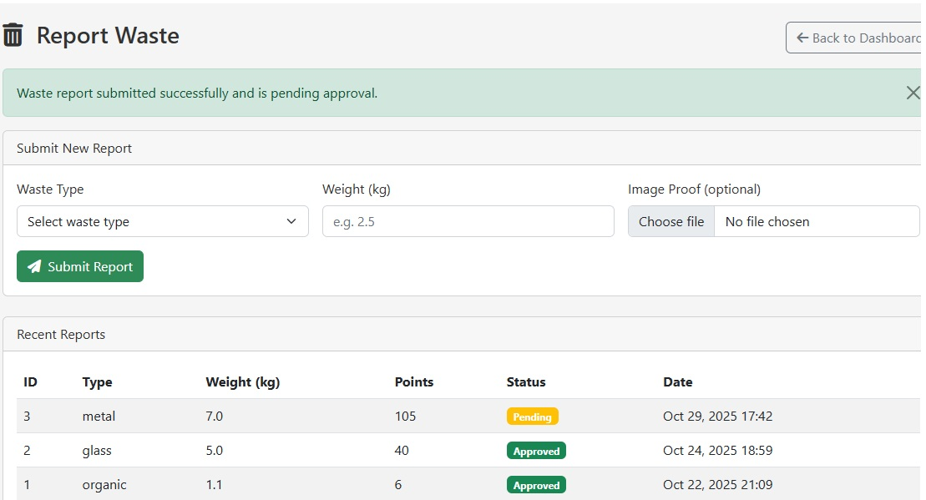

Figure 40:waste reporting

### Reward Center Module

Displays earned reward points for environmental participation and allows users to redeem them for discounts or recognition.  
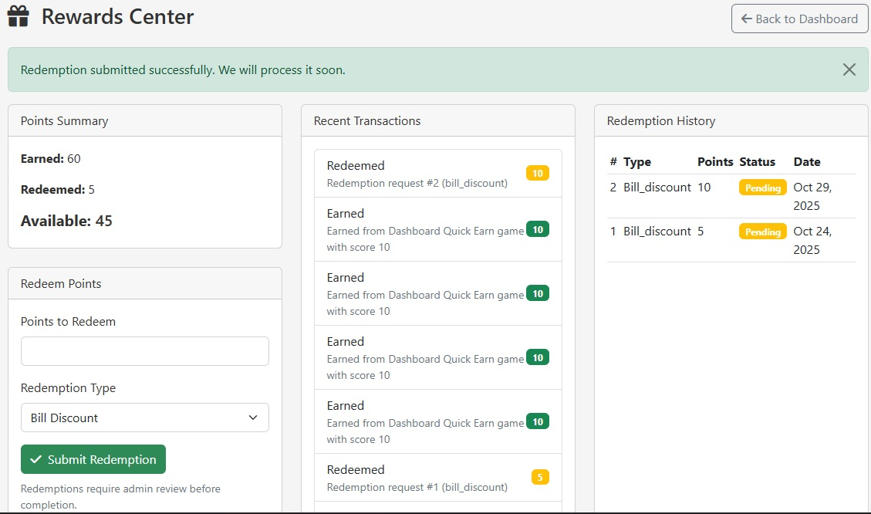

Figure 41:rewarding system

### PAYT Billing Module

Implements Pay-As-You-Throw billing, automatically generating invoices based on total waste produced and applied reward discounts.  
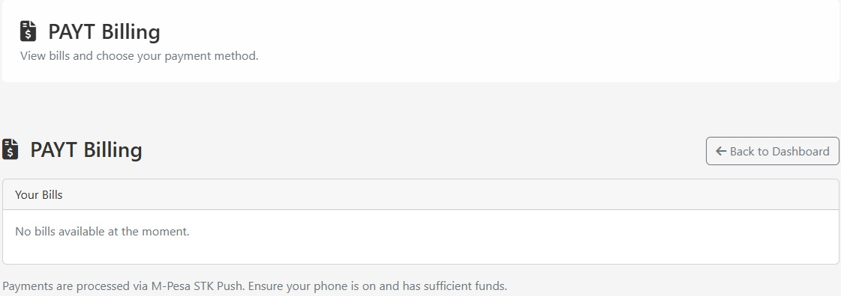

Figure 42:Payt billing

### Collection Schedule Module

Shows the upcoming waste collection timetable per zone, enabling users to view and plan according to their area.  
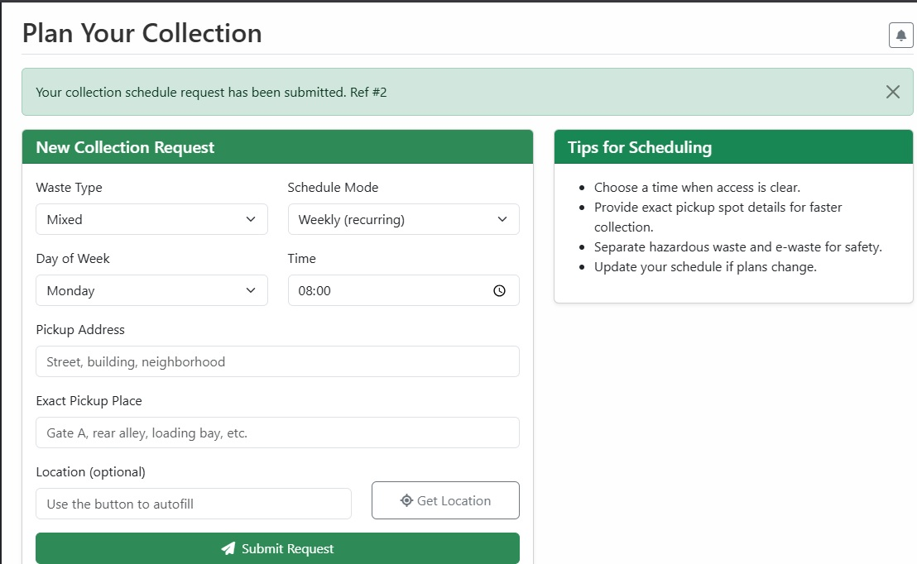

Figure 43:collection scheduling

### Environmental Hub Module

Promotes environmental awareness by displaying articles, recycling tips, and news updates about sustainability initiatives.  
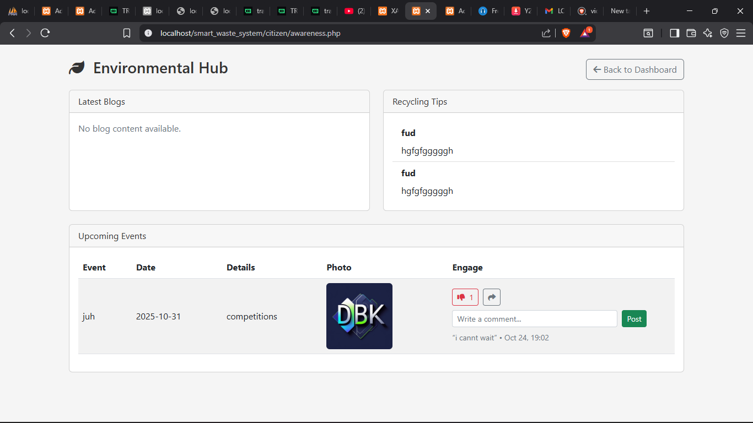

Figure 44:environmental hub

### Q&A Module

Provides users with a searchable library of frequently asked questions and a form to post specific inquiries.  
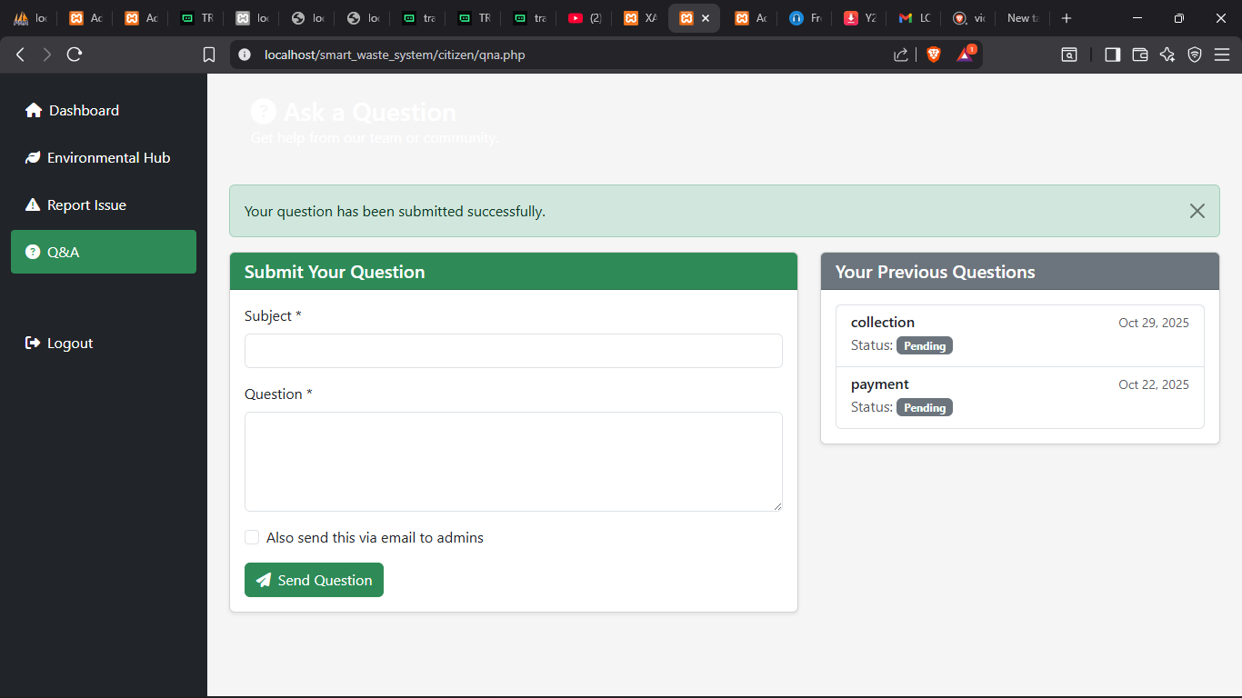

Figure 45:question section

### Feedback Module

Allows citizens to send complaints, suggestions, or compliments to administrators, who can respond directly.  
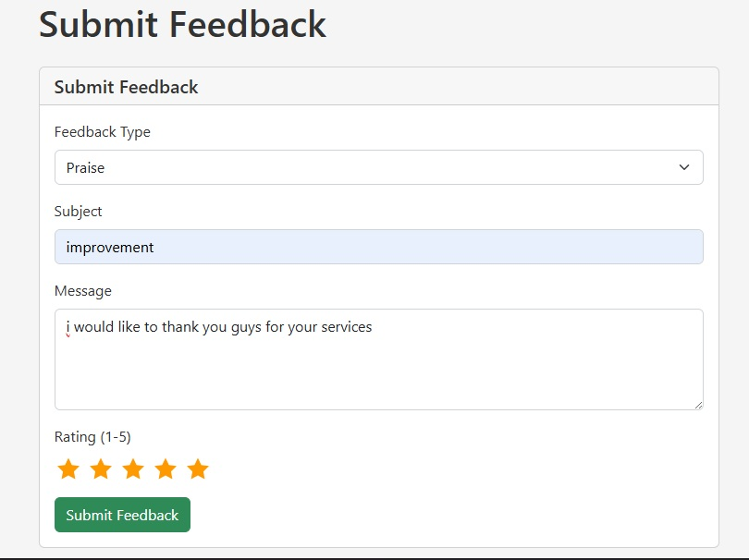

Figure 46:feedback

### Notification and Alert Module

Displays system alerts and messages, including collection reminders, billing updates, or admin responses.  
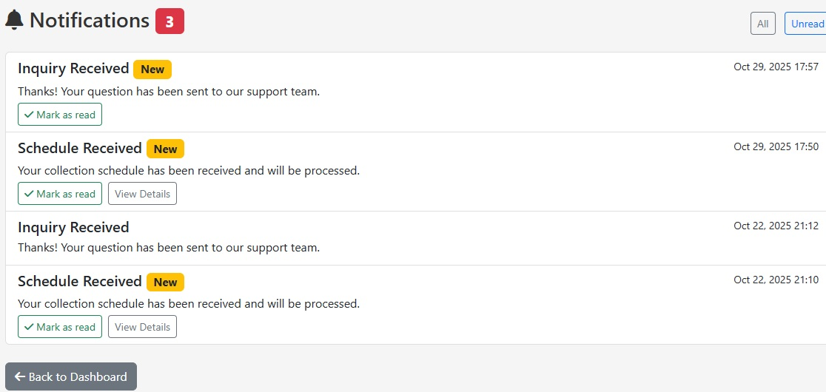

Figure 47:notification and alert

### My Profile Module

Enables users to view and edit personal details such as name, contact, and password.  
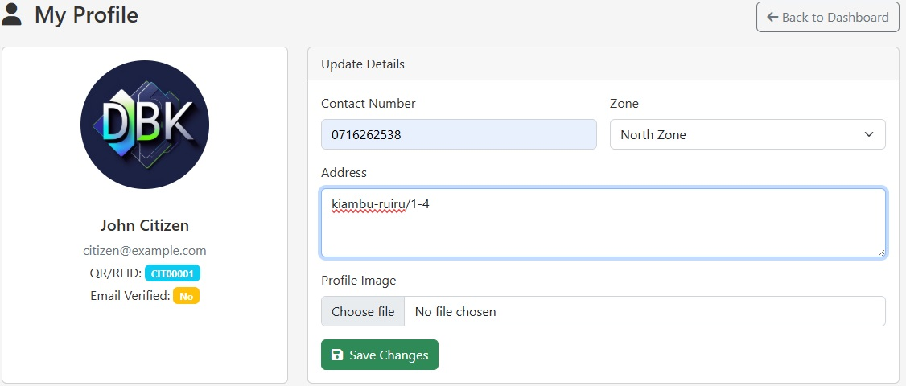

Figure 48:profile setting

### Users Management Module (Admin)

Used by the administrator to manage user accounts, control system access, and monitor activity.  
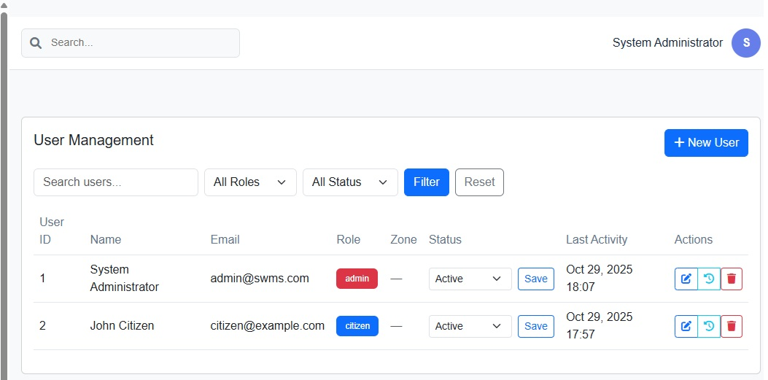

Figure 49:admin user control

# CHAPTER FIVE



## Introduction

This chapter provides a comprehensive overview of the Smart Waste Management System (SWMS) project. It presents the key findings, conclusions, recommendations, references, and appendices related to the project implementation. The system was designed to automate waste management operations, increase efficiency, and enhance citizen engagement through digital technologies. It also provides a foundation for future research and system enhancements.

The appendices that follow include the project’s budget, schedule, Gantt chart, structured questionnaires, and a user guide. These supporting materials give a clear understanding of the system’s design, development process, and operational flow.

## Summary of Findings

The development and implementation of the Smart Waste Management System revealed that automation significantly improves efficiency in municipal waste management. The system replaced traditional manual methods with a digital platform that facilitates faster reporting, improved communication, and transparent monitoring. One of the major findings was that citizen participation increased notably once the reward center and feedback modules were activated. The gamification aspect encouraged users to engage more actively and report waste issues promptly, while the Environmental Hub successfully created awareness about recycling and sustainable living practices.

The Pay-As-You-Throw (PAYT) billing feature introduced fairness and accountability in financial management, ensuring that each user pays according to their waste output. This not only encouraged responsible behavior but also promoted equity and sustainability. The administrator dashboard enabled better oversight of user activity, report tracking, and data analysis, allowing decision-makers to base strategies on accurate information.

Additionally, testing results showed that users found the system intuitive and user-friendly, with an impressive performance across all modules. Security measures, including data encryption and access control, ensured safe storage of sensitive user information. Overall, the system provided an efficient, reliable, and scalable model that can be expanded to other counties in Kenya and integrated with IoT technologies for even greater impact. The Smart Waste Management System therefore stands as a proof of concept for how ICT can transform public service delivery, enhance transparency, and promote environmental sustainability.

## Conclusions

The Smart Waste Management System successfully met its intended objectives by integrating citizens and administrators into a unified digital platform. The system’s implementation has proven that waste collection can be effectively managed using ICT solutions.

Through modules such as waste reporting, billing, rewards, and environmental education, the system promotes accountability and sustainability. The automated notifications and data-driven analytics also enhance efficiency and transparency.

In conclusion, the project demonstrates that technology-driven waste management systems can significantly improve cleanliness, operational efficiency, and citizen participation in urban settings. The Smart Waste Management System stands as a model for Kenya’s transition toward smart and sustainable cities.

## Recommendations

For effective utilization and future expansion of the Smart Waste Management System, the following recommendations are made:

The Nairobi County Government and other local authorities should fully adopt the system to replace traditional waste management approaches. Comprehensive training should be offered to both administrators and citizens to ensure they understand how to use the platform efficiently.

The county should also consider integrating IoT sensors in bins to automate fill-level detection and enhance real-time reporting accuracy. Regular maintenance and updates must be performed to ensure system stability, security, and longevity.

Additionally, awareness campaigns should be conducted to promote user participation and environmental education. Collaborations with private waste contractors and environmental agencies can enhance data sharing and service delivery.

The reward system should be expanded to include partnerships with local recycling companies, supermarkets, and eco-friendly brands. This will motivate more citizens to participate.

Finally, mobile application integration is highly recommended to improve accessibility for users in areas with limited computer access. Periodic system evaluations should also be conducted to identify improvements and measure impact.

## Suggestions for Further Studies

Future researchers are encouraged to focus on enhancing this system by exploring new technologies and extensions such as:

1. Integration of IoT sensors for automatic waste monitoring.
2. Use of machine learning for waste prediction and scheduling optimization.
3. Application of blockchain for secure and transparent PAYT transactions.
4. Development of mobile offline features for rural and low-internet areas.
5. Implementation of voice-command accessibility for special-needs users.
6. Integration with GIS and GPS tracking for mapping waste routes.
7. Research on the economic benefits of digital waste systems.
8. Linking with smart city dashboards for centralized data management.
9. Designing AI chatbots for real-time support.
10. Conducting comparative studies between counties that use SWMS and those that don’t.

## References

1. Nairobi County Government. (2023). *Waste Management Policy Report*.
2. Ministry of Environment and Forestry, Kenya. (2024). *National Waste Management Strategy*.
3. United Nations Environment Programme (UNEP). (2024). *Smart Cities for a Sustainable Future*.
4. World Bank. (2023). *Digital Transformation for Sustainable Cities in Africa*.
5. Waweru, P. (2023). *Design and Implementation of an Automated Waste Tracking System*. University of Nairobi.
6. Otieno, J. & Kamau, S. (2022). *ICT Integration in Urban Sanitation*. Journal of African Smart Systems.
7. Mutiso, L. (2023). *IoT-Based Waste Monitoring*. KCA University.
8. Gitonga, M. (2024). *Smart Billing Systems for Urban Environments*. Technical University of Kenya.
9. UN-Habitat. (2023). *Urban Waste Management Framework for Developing Nations*.
10. Njoroge, J. (2024). *Citizen Participation in Urban Waste Management*. Nairobi Press.
11. Karanja, L. (2023). *E-Government Solutions for Urban Services*. JKUAT.
12. Makori, E. (2024). *ICT Policy and Environmental Planning in Kenya*.
13. Mutua, K. (2022). *Sustainability and Digital Governance*. African Journal of ICT.
14. UNDP. (2024). *Innovation in Waste and Recycling Systems*.
15. Kaburu, C. (2023). *Waste-to-Energy Approaches in Developing Economies*.
16. Kagiri, B. (2024). *Digital Data Management for Smart Cities*.
17. Githae, P. (2023). *Application of PHP and MySQL in Government Systems*.
18. African Development Bank. (2024). *Smart City Implementation Toolkit*.
19. Kimani, R. (2025). *Towards a Greener Kenya: ICT and Environment*.

## Appendix

### Appendix A: Project Budget

|  |  |  |  |  |
| --- | --- | --- | --- | --- |
| **Item** | **Description** | **Qulity** | **Unit Cost (Ksh)** | **Total Cost (Ksh)** |
| Laptop | Development and testing | Lenovo | 65,000 | 65,000 |
| Internet Subscription | 6 months | Safaricom home fibre | 3,000 | 18,000 |
| Web Hosting | Domain & hosting | Github webpages and | 9,500 | 9,500 |
| Software Tools | VS Code, XAMPP, Draw.io |  | 5,000 | 5,000 |
| Stationery & Printing | Documentation |  | 3,000 | 3,000 |
| Transport | Research and testing |  | 6,000 | 6,000 |
| Power Backup | UPS & accessories | 1 | 4,500 | 4,500 |
| Miscellaneous | Contingency |  | 4,000 | 4,000 |
| **Total** |  |  |  | **115,000 Ksh** |

Table 19:Project Budget

### Appendix B: Project Schedule

|  |  |  |  |
| --- | --- | --- | --- |
| **Activity** | **Start Date** | **End Date** | **Duration** |
| Project Proposal & Approval | May 1, 2025 | May 15, 2025 | 2 weeks |
| Requirements Gathering | May 16, 2025 | June 5, 2025 | 3 weeks |
| System Design | June 6, 2025 | July 10, 2025 | 5 weeks |
| Database Development | July 11, 2025 | August 5, 2025 | 3.5 weeks |
| Frontend Development | August 6, 2025 | September 10, 2025 | 5 weeks |
| Backend Integration | September 11, 2025 | October 5, 2025 | 3.5 weeks |
| System Testing | October 6, 2025 | October 25, 2025 | 3 weeks |
| Final Documentation | October 26, 2025 | November 1, 2025 | 1 week |

Table 20:Project Schedule

### Appendix C: Project Gantt Chart

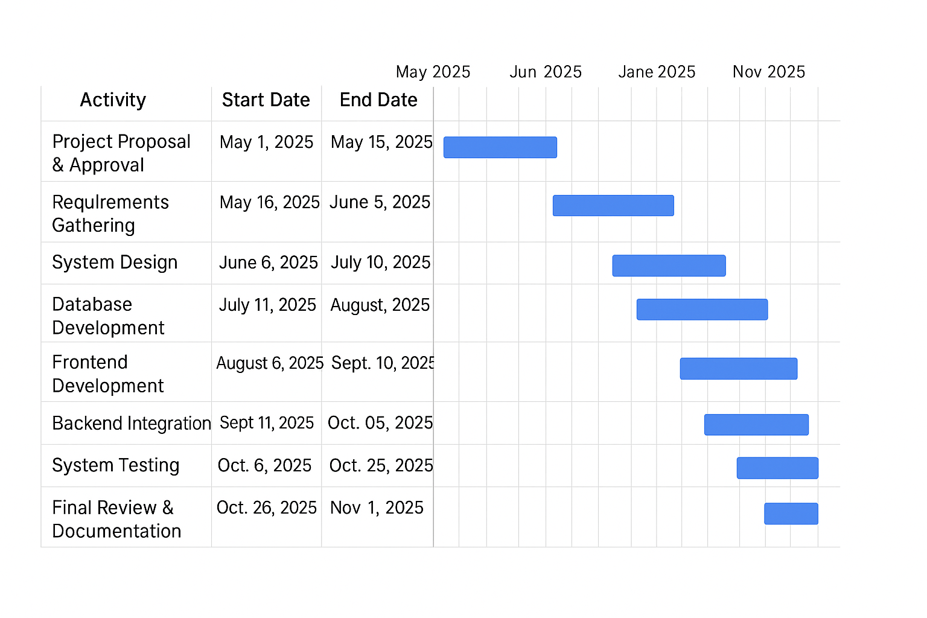

Figure 50:Project Gantt Chart

### Appendix D: Structured Questions

**Part I: Yes/No Questions Tick One**

|  |  |  |
| --- | --- | --- |
| **Question** | **Yes** | **No** |
| 1. Do you know about the Smart Waste Management System? | ☐ | ☐ |
| 2. Have you ever reported waste through the system? | ☐ | ☐ |
| 3. Did you receive a confirmation after submitting a report? | ☐ | ☐ |
| 4. Do you think the system is easy to use? | ☐ | ☐ |
| 5. Does the system improve communication with the county? | ☐ | ☐ |
| 6. Have you accessed the Reward Center? | ☐ | ☐ |
| 7. Have you used the PAYT Billing system? | ☐ | ☐ |
| 8. Do you find billing charges fair? | ☐ | ☐ |
| 9. Have you ever used the Environmental Hub? | ☐ | ☐ |
| 10. Does the system encourage recycling? | ☐ | ☐ |
| 11. Have you ever given feedback? | ☐ | ☐ |
| 12. Did you get an admin response? | ☐ | ☐ |
| 13. Are collection schedules followed as shown? | ☐ | ☐ |
| 14. Do you feel data is secure? | ☐ | ☐ |
| 15. Would you recommend the system to others? | ☐ | ☐ |

**Part II: Multiple Choice Questions (select and tick or mark one)**

1. How often do you use the system?  
   A) Daily B) Weekly C) Monthly D) Rarely
2. Which feature do you use most?  
   A) Report Waste B) Billing C) Rewards D) Environmental Hub
3. How would you rate the system’s speed?  
   A) Excellent B) Good C) Fair D) Poor
4. How user-friendly is the dashboard?  
   A) Very easy B) Easy C) Average D) Difficult
5. Which device do you use most?  
   A) Mobile B) Laptop C) Desktop D) Tablet
6. How reliable are system notifications?  
   A) Always B) Sometimes C) Rarely D) Never
7. How satisfied are you with the reward system?  
   A) Very B) Moderately C) Slightly D) Not at all
8. How do you rate the billing transparency?  
   A) Very clear B) Clear C) Average D) Poor
9. How responsive is admin support?  
   A) Excellent B) Good C) Fair D) Poor
10. How would you rate the Environmental Hub content?  
    A) Excellent B) Good C) Fair D) Poor
11. Is the system design appealing?  
    A) Very B) Average C) Fair D) Poor
12. Would you pay for the service if it improves cleanliness?  
    A) Yes B) Maybe C) Not Sure D) No
13. What motivates you to use the system most?  
    A) Rewards B) Cleanliness C) Billing D) Awareness
14. How satisfied are you with updates?  
    A) Very B) Somewhat C) Neutral D) Not satisfied
15. Would you like a mobile app version?  
    A) Yes B) Maybe C) Not sure D) No

**Part III: Open-Ended Explanatory Questions (15)**

1. If yes, explain how the system improved your waste reporting experience.
2. How has the reward system motivated your participation?
3. Describe your experience with billing transparency.
4. How has the Environmental Hub influenced your behavior?
5. What challenges did you face using the system?
6. How did feedback from the admin help you?
7. What new feature would you like added?
8. How has the system improved communication in your area?
9. Explain how the schedule module helps you plan waste disposal.
10. What do you like most about the system?
11. What part of the system needs improvement?
12. How reliable are notifications based on your experience?
13. What impact has the system had on environmental awareness?
14. Would you recommend this system for county-wide use? Why?
15. How do you think technology can improve waste management further?

### Appendix E: User Guide

System Access:

1. Open the web browser and navigate to the system’s URL.
2. Click *Login* or *Create Account*.

Citizen Functions:

* Report Waste: Fill in details, upload image, and submit.
* View Collection Schedule: Check dates for your area.
* Reward Center: View and redeem points.
* Billing (PAYT): View invoices and make payments.
* Feedback: Send suggestions or complaints.
* Environmental Hub: Read tips and news.
* My Profile: Update your details and password.

Administrator Functions:

* Manage Users: Add/edit/delete user accounts.
* Review Reports: Verify and mark waste reports as resolved.
* Generate Reports: Analyze trends and generate summaries.
* Update Environmental Content: Post new tips or blogs.
* Send Notifications: Alert users about updates.

Logout:  
Always click *Logout* after your session for data security.

## Appendix F: Sample Code

The code shows customer dashboard

Figure 51:customer dashboard

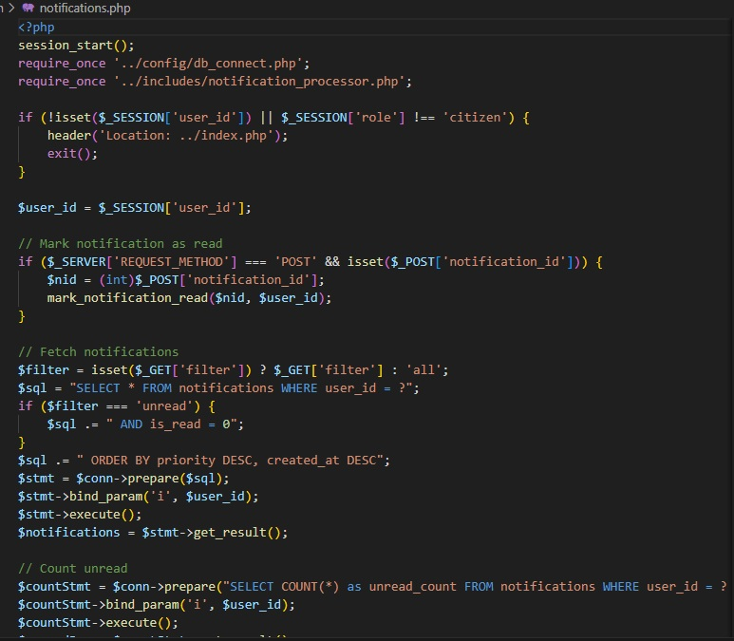This code is for notification

Figure 52:customer notification

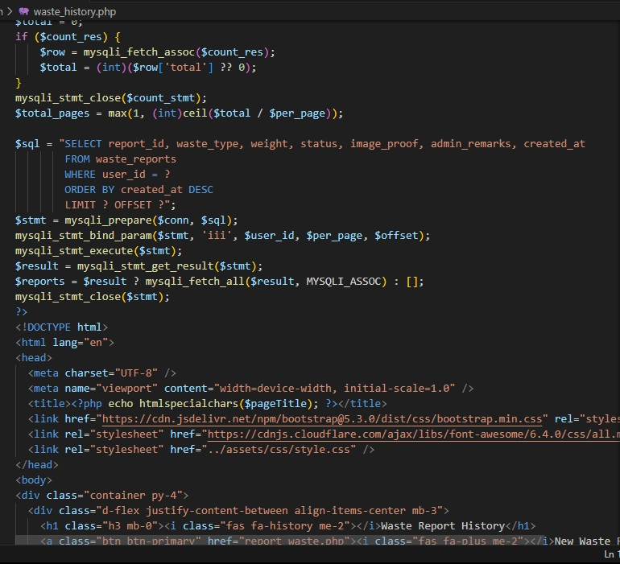This section of code shows waste history

Figure 53:waste history